IB Math HL 1 21D Fundamental Theorem of Calculus and Definite Integral Name

|  |  |
| --- | --- |
| **Antiderivative**  If , then  is an antiderivative  of  **Indefinite Integral**    Represents all antiderivatives of | **Riemann Sum**    Sum of n rectangles  approximating the area under .    Sum of infinitely many rectangles of infinitesimal width is the **EXACT area** under  on the interval . |

**Fundamental Theorem of Calculus**

 **=**

|  |  |
| --- | --- |
| If  is continuous with antiderivative , then . |  |
|  |

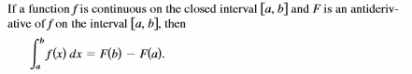

Example 1)

a. Use 20 right-hand rectangles to approximate.

Sigma Notation: Rounded to 4 decimal places:

b. Use graphical evidence to evaluate .

b. Use the FTC to evaluate .

* Proof of FTC (Calculus by Larson and Edwards)

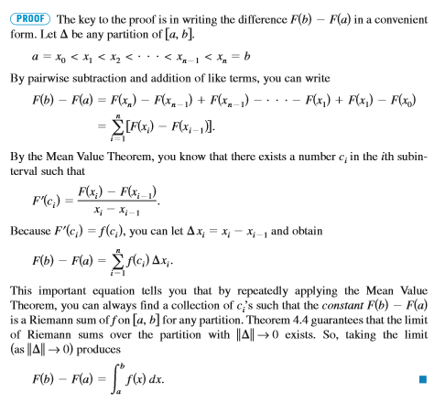

Example 2) By FTC, evaluate the definite integral; .

1.  b. 