Section 10.C IB PreHL Warm Up on Secant, Coscecant, and Cotangent
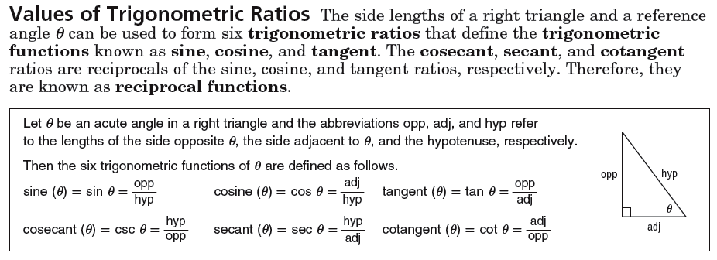
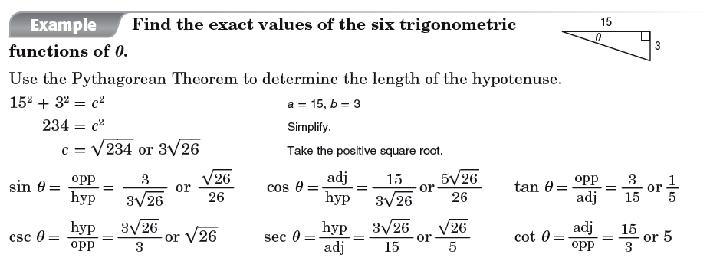
Exercise 1:
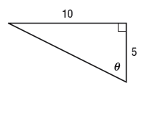
Exercise 2:
