Pre HL Ch 8 Exit Slip #1: In order to earn full credit, show your work.

Name: ____________________ Period: ___________

1.
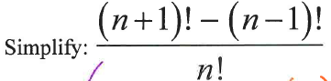

2. 48 people are about to get on a double-decker bus which seats 24 people on each level. However, 8 people refuse to travel upstairs, and 6 people refuse to travel downstairs. How many ways are there of choosing which passengers travel upstairs and which passengers travel downstairs?

3. 10 people came to a book club to discuss "You are joking, Mr. Feynman". The seats are arranged in a circle facing toward center.

a. How many different ways can the seats be arranged ?

b. How many different ways can the seats be arranged when the couple, John and Jill, in the group are allowed to sit together?

