IB Math HL 2: Chapter 15 IB Questions #1
1 | 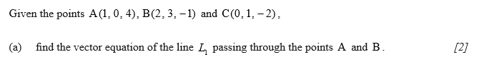
2 | 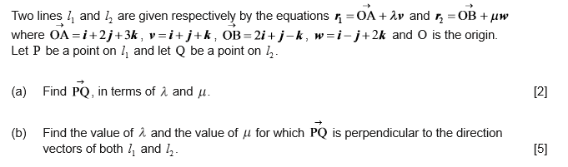
3 | 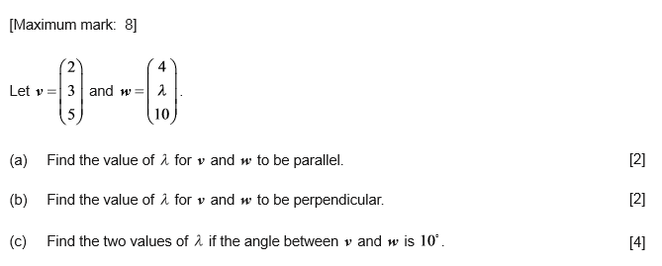

4 | 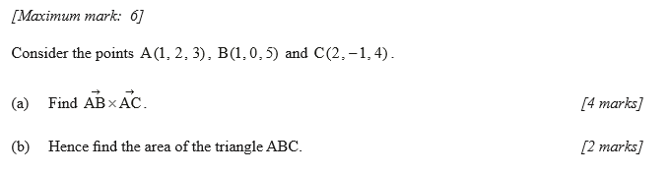
5 | 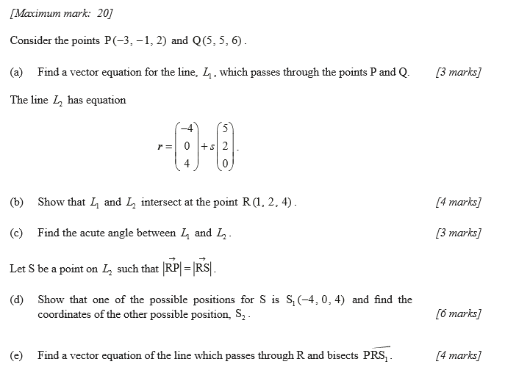
6 | 