[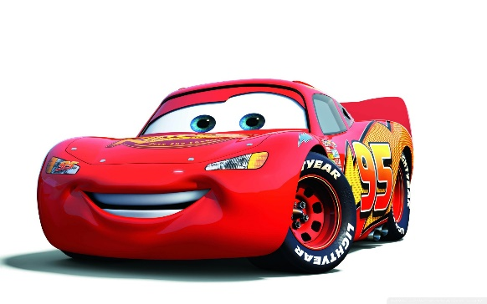](http://www.google.com/url?sa=i&rct=j&q=&esrc=s&frm=1&source=images&cd=&cad=rja&uact=8&ved=0CAcQjRxqFQoTCJDu_92-0scCFYKjiAodcJEA0Q&url=http://oppositelock.kinja.com/2014-f1-cars-have-me-changing-my-mind-about-turbos-1542938057&ei=29jjVdCUMYLHogTwooKIDQ&psig=AFQjCNH4dBvuC5UIYkoL93QDUZeZ7pW-Ig&ust=1441081945865150)**IB Math HL2: Integration by parts and Repeated by parts Name: _____________ Period: ________**

**Integration by parts:** 

Do not Drink and Derive!







Answers:

Ex 1) , Ex 2) , Ex3) 

Ex 4) , Ex 5) 