**IB Math HL1 Kinematics IB Questions** Name: ____________________

Calculator is okay.

|  |  |
| --- | --- |
| 1 |  |
| 2 |  |
| 3 |  |
| 4 |  |
| 5 |  |
|  |  |
| 6 |  |
|  |  |

|  |  |
| --- | --- |
| Challenge |  |

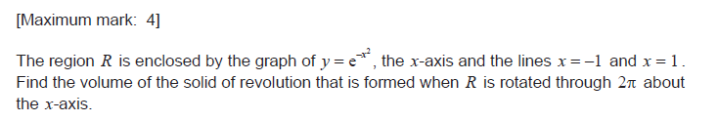

|  |  |
| --- | --- |
|  |  |

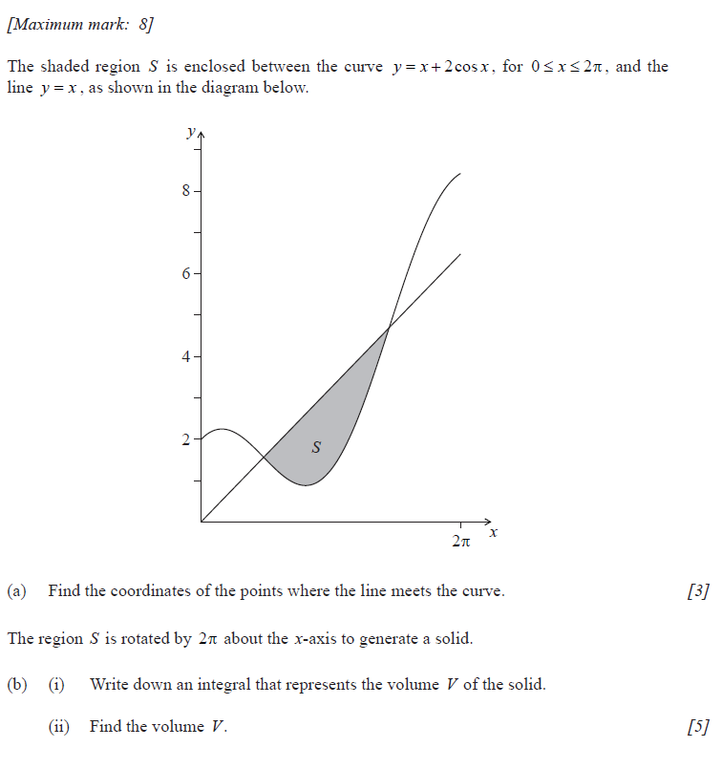

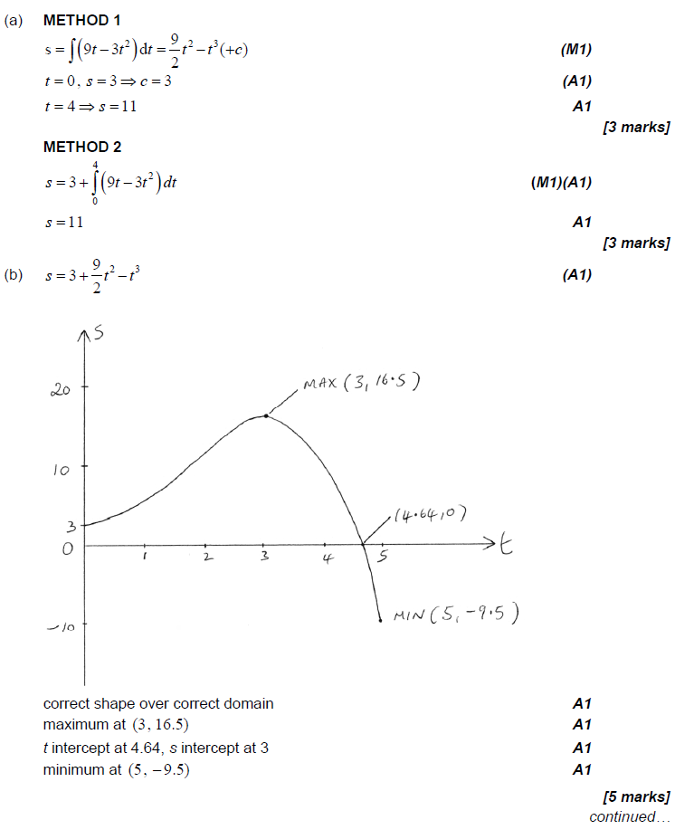

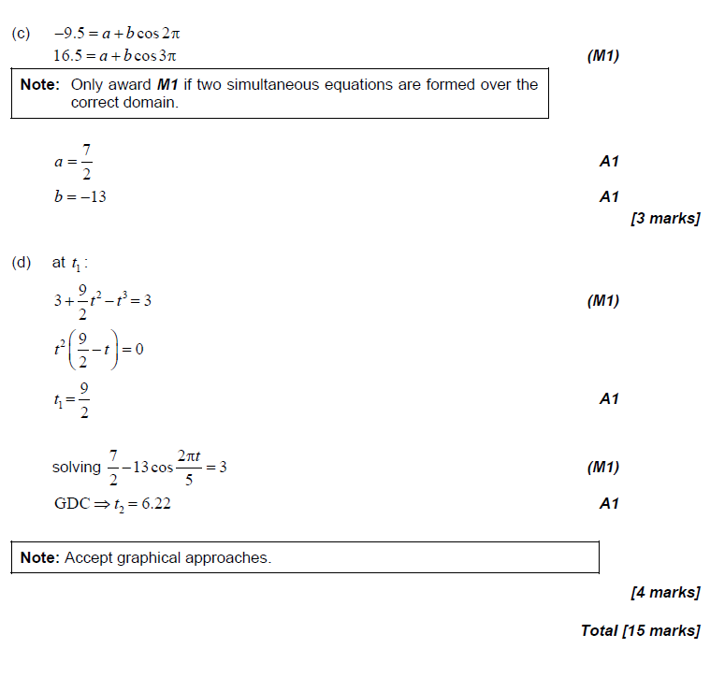

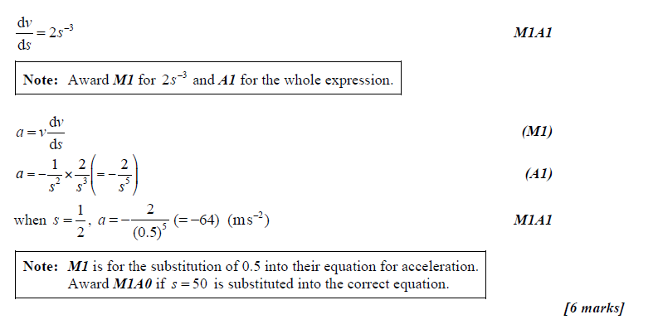

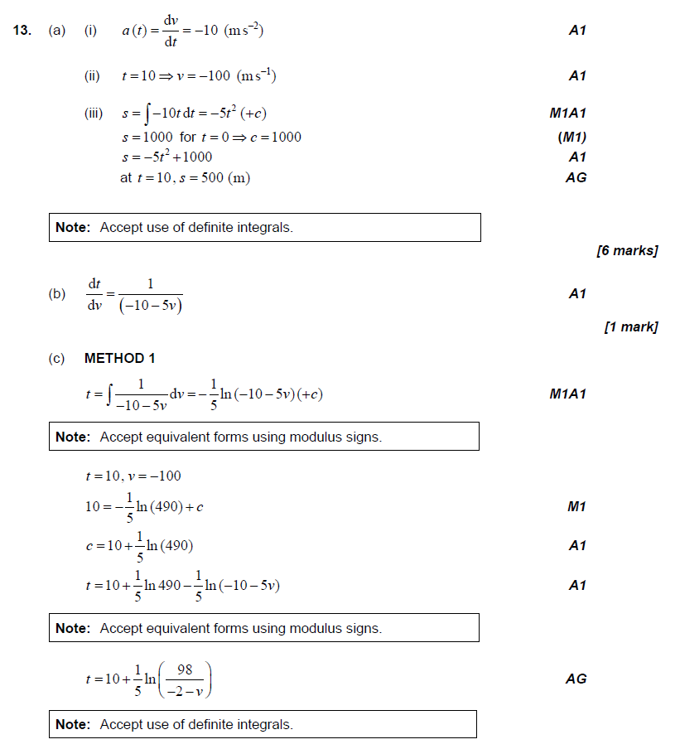

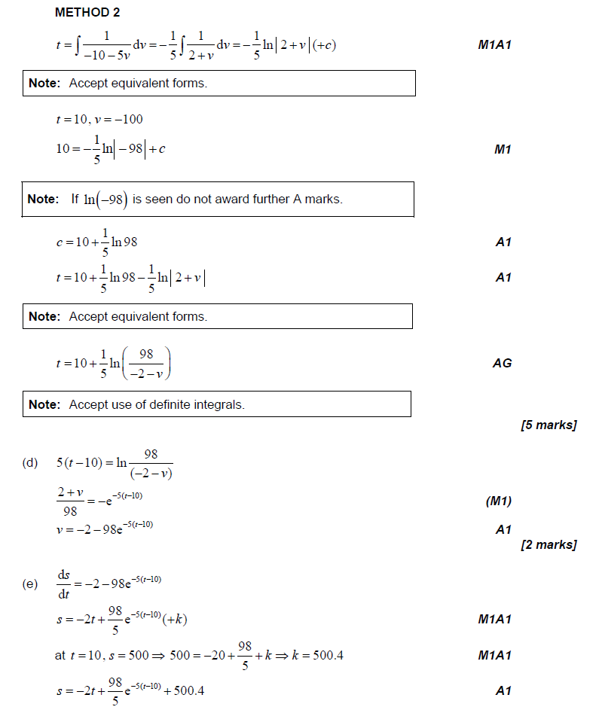

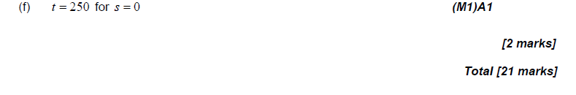

1. A particle is moving along a line so that is velocity is  feet per second at time t.

1. Determine the speed is increasing and decreasing when t = 3. Show your reasoning.
2. What is the displacement (net) of the particle on the time interval [1, 5].
3. What is the total distance traveled by the particle on the time interval [1, 5].

2. Given , , and, Find f(x).

3. Find the area of the region bounded by the given equations.

a , the *x*-axis, the *y*-axis, and .

b. , , and 

c.  and 