IB Math Pre HL Sine, Cosine, and Tangent Parent Functions Warm up

|  |  |  |  |  |  |  |  |  |  |
| --- | --- | --- | --- | --- | --- | --- | --- | --- | --- |
|  |  |  |  |  |  |  |  |  |  |
|  |  |  |  |  |  |  |  |  |  |

1. 

a. Complete the table without a

calculator.

Think about how you can approximate this without a calculator!

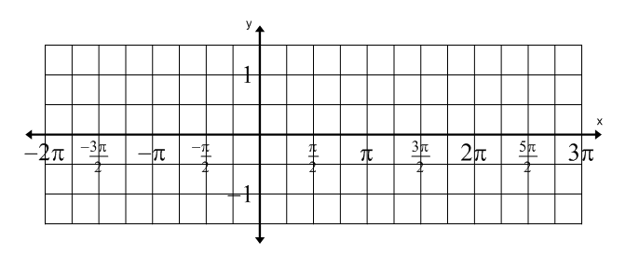b. Plot the points from your table on the graph and draw a smooth curve through the points.

c. Remembering that  is a periodic function, extend the curve to fill the domain shown in the graph.

d. Use your graphing calculator, graph  to check your work.

Put your calculator in radians mode. TI-Nspire: Doc, Settings, change Angle to Radian

TI-84 or 83: Mode, move cursor to Radian, press Enter

e. Identify the following for .

Domain: Range: Amplitude:

Period: Equation of the axis: y-intercept:

2. 

Repeat steps a – d using .

|  |  |  |  |  |  |  |  |  |  |
| --- | --- | --- | --- | --- | --- | --- | --- | --- | --- |
|  |  |  |  |  |  |  |  |  |  |
|  |  |  |  |  |  |  |  |  |  |

e. Identify the following for .

Domain:

Range:

Amplitude:



Period:

Equation of the axis:

y-intercept:

3. 

a. Complete the table without a calculator.

|  |  |  |  |  |  |  |  |  |  |  |  |  |  |
| --- | --- | --- | --- | --- | --- | --- | --- | --- | --- | --- | --- | --- | --- |
|  |  |  |  |  |  |  |  |  |  |  |  |  |  |
|  |  |  |  |  |  |  |  |  |  |  |  |  |  |

b. Plot the points from your table on the graph and draw a smooth curve through the points.

c. Extend the curve to fill the domain shown in the graph.



d. Use your graphing calculator, graph  to check your work.

e. Identify the following for .

Domain: Range: Amplitude:

Period: Equation of the axis: y-intercept: