IB Pre HL1 Sinusoidal Modeling Name: _________________

Chemotherapy

***Work with your group members and when you finished, let Ms. Shim check the answers by raising your hands. Ms. Shim will choose one of the papers randomly to check. Make sure all of your group members understand the process, Ms. Shim might quiz one of you.***

Ima Patient has cancer. She must have a chemotherapy treatment once every three weeks. One side effect is that her red blood cell count goes down and then comes back up between treatments. On January 13 (day 13 of the year), she gets a treatment. At that time, her red blood cell count is at a height of 800. Halfway between treatments, the count drops to a low of 200. Assume that the red blood cell count varies sinusoidally with the day of the year, x.

1. Draw the graph of the sinusoid on the given axes. Show enough cycles to fill the graph paper.



1. Write a particular equation for the(circular) sinusoid. It is recommended that you use the cosine function. Show your work such as period and etc.
2. Enter your equation in your grapher. Plot the graph using the window shown. Explain the graph verified that your equation is correct.
3. Ima feels “good” if the red blood cell count is 700 or more, “bad” if the count is 300 or less, and “so-so” if the count is between 300 and 700. How will she be feeling on her birthday, March 19? Explain how you arrived at your answer.
4. Show on your graph (above) the interval of dates between which Ima will feel “good” as she comes back from the low point after the January 13 treatment. State the values of x for the interval of feeling “good”.

Ferris Wheel:

As you ride a Ferris Wheel, your distance from the ground varies sinusoidally with time.

When the last seat is filled, your seat is at the position shown. Let  be the number of seconds

since the wheel started. You find it takes you seconds to reach the top, which is feet

above ground, and that the Wheel makes one full revolution every seconds. If the diameter

of the wheel is feet:

a. Find an equation that will determine your height, , above the ground at any time .

b. How high above the ground are you after  seconds?

c. How long does it take for your to be ft above the ground for the second time?

Rehearsal:

The average depth of the water at a particular point on the beach varies sinusoidally with time due to the motion of the tides. The figure shows the depth, y, measured in feet, at such a point as a function of x, measured in hours after midnight at the beginning of January 1. The particular equation of the sinusoid is



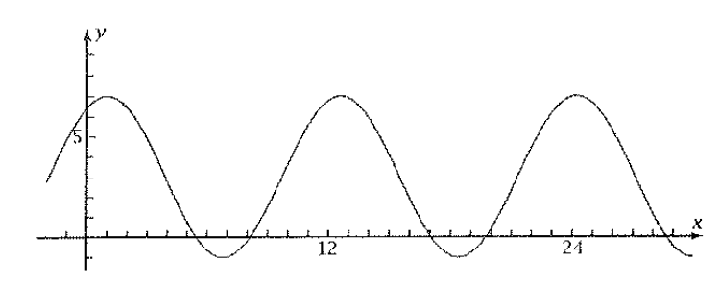

1. What is the deepest the water gets? What is the first time on January 1 at which the water is this deep? What is the period of this function?
2. Where the graph dips below the x-axis, the water is completely gone, leaving the pint on the beach out of the water. At what time does the lowest tide first occur on January 1? How deep a hole would you have to dig in the sand so that water would flow into it at that time?
3. Calculate the depth of the water at 4:00 pm on January 1. Who that the answer agrees with the graph?
4. Find the graphically the first interval of times on January 1 for which the water is completely gone.