IB Math PreHL 12B&D Sine & Cosine Parent Functions

1. 

a. Complete the table without a calculator.

|  |  |  |  |  |  |  |  |  |  |
| --- | --- | --- | --- | --- | --- | --- | --- | --- | --- |
|  |  |  |  |  |  |  |  |  |  |
|  |  |  |  |  |  |  |  |  |  |

Think about how you can approximate this without a calculator!

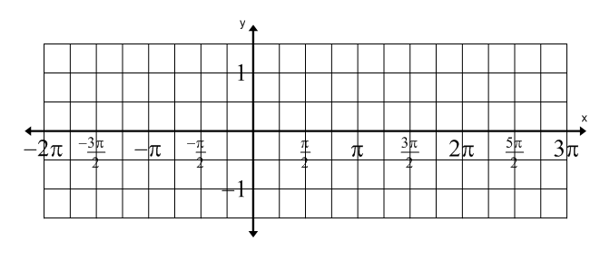b. Plot the points from your table on the graph and draw a smooth curve

through the points.

c. Remembering that  is a periodic function, extend the curve to fill the

domain shown in the graph.

d. Use your graphing calculator, graph  to check your work.

Put your calculator in radians mode. TI-Nspire: Doc, Settings, change Angle to Radian

TI-84 or 83: Mode, move cursor to Radian, press Enter

e. Identify the following for .

Domain: Range:

Amplitude: Period:

Equation of the axis: y-intercept:

2. 

a. Complete the table without a calculator.

|  |  |  |  |  |  |  |  |  |  |
| --- | --- | --- | --- | --- | --- | --- | --- | --- | --- |
|  |  |  |  |  |  |  |  |  |  |
|  |  |  |  |  |  |  |  |  |  |

b. Plot the points from your table on the graph and draw a smooth curve

through the points.



c. Remembering that  is a periodic function, extend the curve to fill the

domain shown in the graph.

d. Use your graphing calculator, graph  to check your work.

Put your calculator in radians mode. TI-Nspire: Doc, Settings, change Angle to Radian

TI-84 or 83: Mode, move cursor to Radian, press Enter

e. Identify the following for .

Domain: Range:

Amplitude: Period:

Equation of the axis: y-intercept: