Pre HL Ch 7 IB Questions: Name: _____________________________
1 | 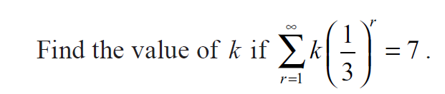
2 | 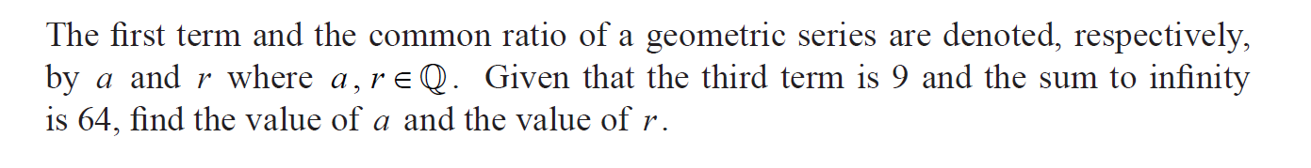
3 | 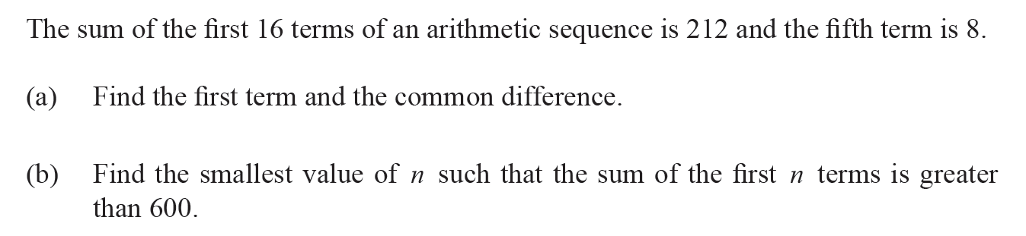
4 | 