**IB Pre HL 24I Laws of Probability**

Warm up. A box of 18 chocolates has 6 chocolates with a Hard center

and 12 with a Soft center. Find the following.

a)  b) 

c)  d) 

**Conditional Probability: Given two events A and B, the conditional probability of A given B is the probability that A occurs given that B has already occurred.**



Example 1) In a class of 25 students, 14 like pizza and 16 likes iced coffee. One student likes neither and 6 students like both. One student is randomly selected from the class. What is the probability that the student

a) likes pizza b) likes pizza given that he or she likes iced coffee?

Example 2) A student who is traveling by train through Europe decides not to buy a ticket for the train. The train is traveling through both France and Germany and as such he may be asked to show his ticket to either the French or the German train guard.

The probability of being caught without a ticket by the German guard is 0.8, and the probability of getting caught by the French guard is 0.3. The probabilities of each are independent from one another.

Given he was caught, find the probability that he was caught by,

i) the French guard,

ii) the German guard.

.

Example 3)



Example 4)

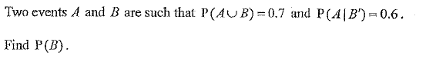

Exit Slip)

1. Given that P(A)=0.6, P(B)=0.4 and that A and B are independent events. Find the probability the events

a)  d) 

c) 

2. Sandy is likely to get up on time for school on two out of three days. If she gets up on time for school, she will actually get to school on time p % of the time. If she gets up late, she will get to school on time 25% of the time. There is a 50-50 chance that Sandy did get up on time, even though she arrived at school late. Find p.