IB PreHL 24L Baye’s Theorem
We already know about conditional probabilities:
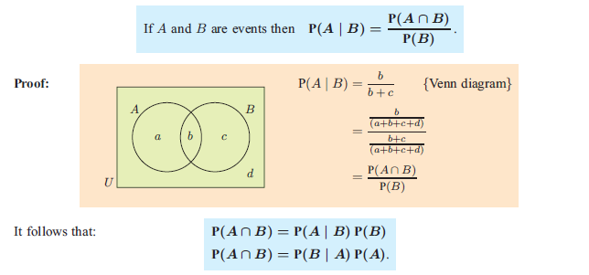

BAYES’ THEOREM
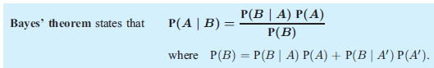

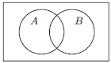
Let’s confirm Bayes’ Theorem using Venn Diagrams & our understanding of dependent events:
Why are the numerators equivalent?
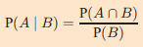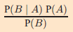

Where:
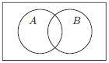
Example: A can contains 4 blue and 2 green marbles. One marble is randomly drawn from the can without replacement and its color is noted. A second marble is then drawn. Find the probability that
a) the second marble is blue.
b) the first marble was green given that the second marble is blue.

Example) p 772 #5
A new blood test has been designed to detect a form of cancer. The probability that the test correctly identifies someone with the cancer is 0.97, and the probability that the test correctly identifies someone without the cancer is 0.93. Approximately 0.1 % of the general population are known to contract this cancer.
When a patient has a blood test, the test results are positive for the cancer. Find the probability that the patient actually has the cancer.

Practice) The Probabilities that Kim's mother and father will be alive after ten years are 0.99 and 0.98 respectively. What is the probability that if only one of them is alive after ten years, it is his mother?

