IB Pre-HL Name:________________________

Semester 2 Final Review Chapters 7, 9, 10-12

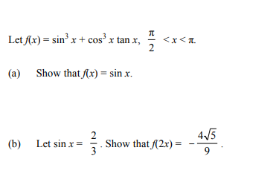
1.

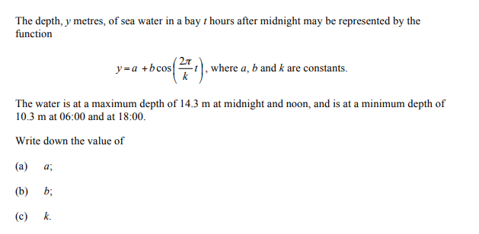
2.

3.

4. 5.

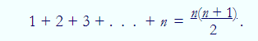
6. With induction:

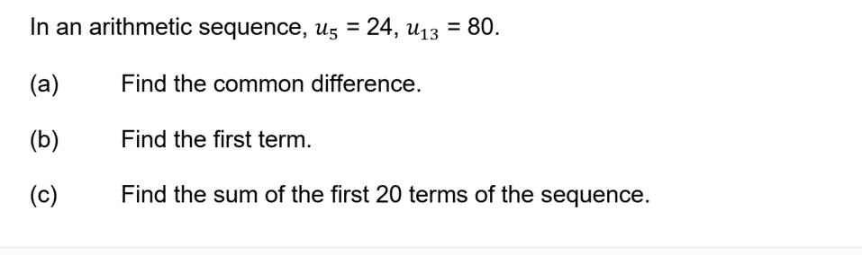
7.

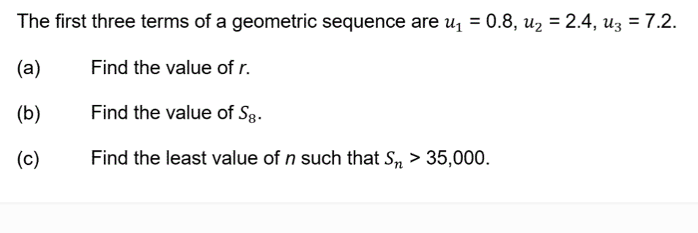
8.

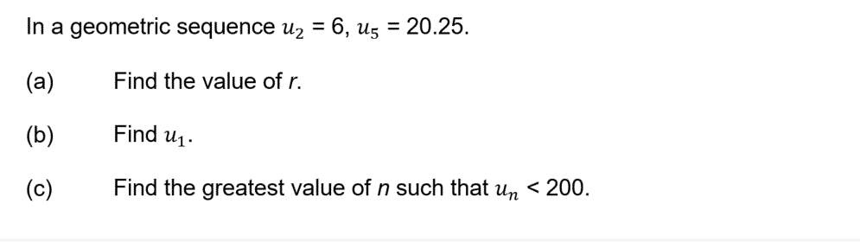
9.

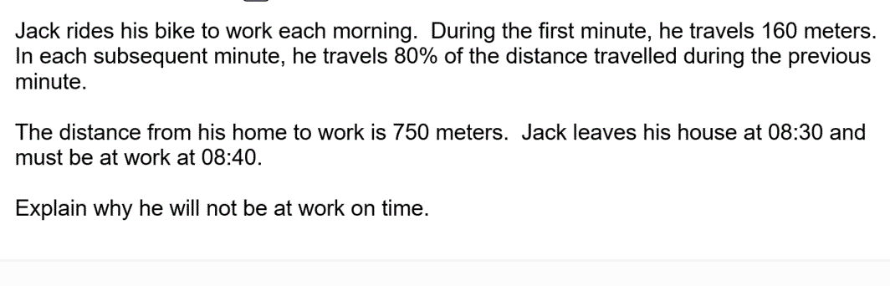
10.

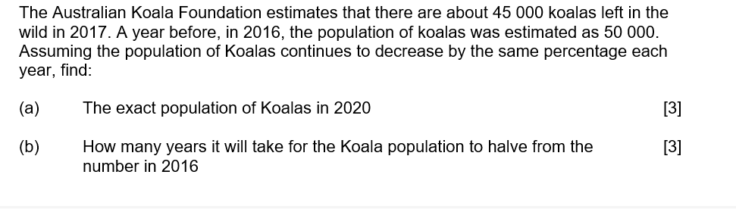
11.

