IB Math HL2: Chapter 16 IB Questions
1 | 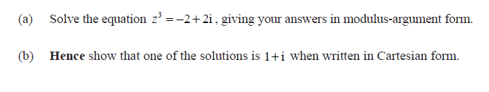
2 | 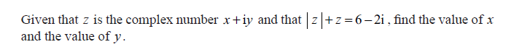
3 | 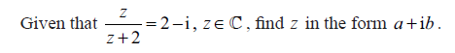
4 | 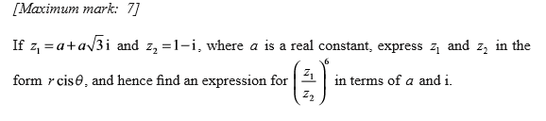
5 | 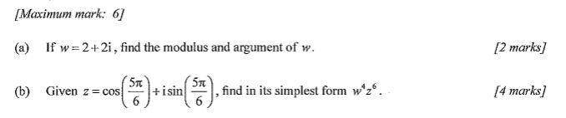
6 | 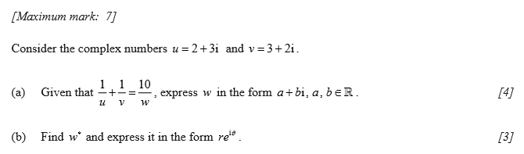
7 | 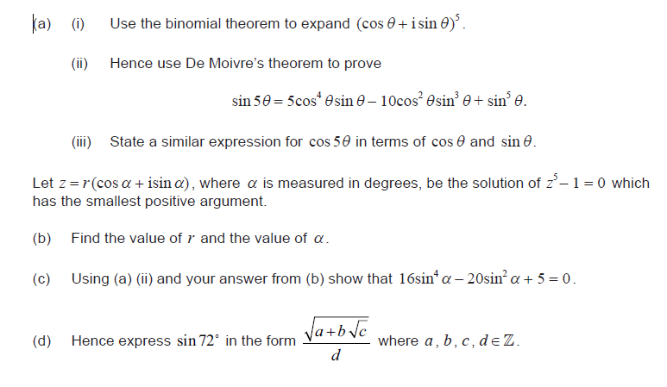
8 | 