Dear IB HL2 Students,
You have completed the first draft of the IB Math HL internal assessment. I hope you are proud of your paper. During this project, I have observed your hard work, resilience, perseverance, creativity, willingness to take risks, disappointment, remaining open minded, maintaining your sense of humor, and more. Most of all, you never gave up.
I want to remind you that the IA final draft of the hard copy is due on November 8 at the beginning of the class and again viaTurnitin.com by 4:00 pm. I want you to use the following guideline for your final draft.
- Cover page: Show your personality on this page (no page number)
- Page number on each page at the upper right corner (NO NAME)
- MLR format for citation
- The bibliography on the last page.
- Do your best staying within the 8-15 page limits with 1.5 spacing.
- Print one sided and hold your papers with a mini bind clip (DO NOT STAPLE YOUR DOCUMENT)
- Reminder: submit it again via Turnitin.com by 4:00 PM (Nov. 8)
In addition, I want you be aware that IB management published the following new guidelines on “the Academic honesty policy”. Please double check your paper via turnitin.com and be responsible. If your paper is selected, it will be uploaded into the IB site.
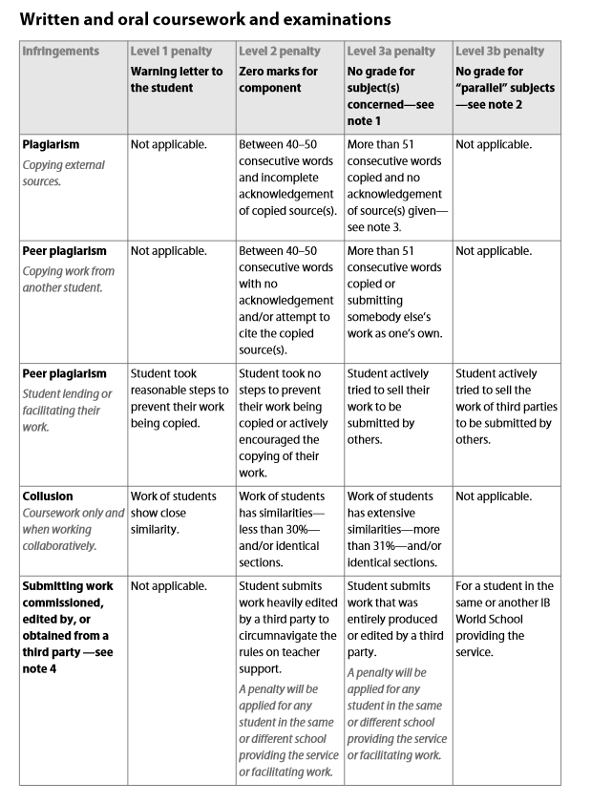
I will be gone for the IB new curriculum training, 11/1-11/4, in Denver.
The new unit (Vectors and 3-D Geometry) will start on 11/5. I look forward to it.
You rock!

