Pre HL IB Questions (1st and 2nd Semesters)

Chapter 1

1. Let . Solve the inequality,

2. The diagram below show the graph of , ,and a quadratic function**,** that all intersect in the same two points. Find the equation of the quadratic function and the intersecting coordinates.



3. The equation  has roots  and . Given , find the value of a.

4. Express  in the form  where .

5. Prove that the equation  has two distinct real roots for all values of 

Chapter 2

|  |  |
| --- | --- |
| 2. | 3. Given  and  a) Calculate  b) |
|  | 4. Find all values of x that satisfy the inequality, . |
| 5. |  |

Chapter 3

6. Without using a calculator, Solve

a) .

b) 

|  |  |
| --- | --- |
| 2. | Using your Graphing Calculator: |

Chapter 4

|  |  |
| --- | --- |
| 1. |  |
| 2. |  |
| 3. |  |
| 4. |  |
| 5. |  |
| 6. |  |
| 7. |  |
| 8. |  |

Chapter 5

Transformation

Chapter 6

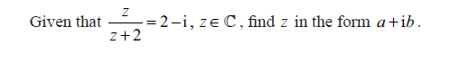

1. Given z is the complex number, , and . Find 
2. Find  when 



2. 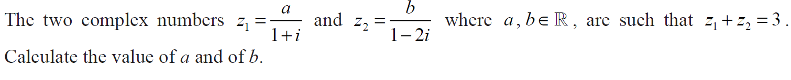
3. 7
4.  is a root of . Find all possible values of a and b.

Chapter 7

|  |  |
| --- | --- |
| 1 |  |
| 2 |  |
| 3 |  |
| 8 |  |

Chapter 9 Induction:

1. By mathematical induction, prove that  for all integers n, .
2. Prove, by mathematical induction, that, , is divisible by 4.

Chapter 10, 11, 12, and 13: Trigonometry:

|  |  |
| --- | --- |
| 1. |  |
| 2. | Graphing Calculator Question: |
| 3. |  |
| 4. |  |
| 5. |  |
| 6. |  |
| 7. | (b) Find an expression for when the dear population is 815 deer. |
| 8. |  |
| 9. |  |
| 10. |  |
| 11. |  |

**Ch 24 Exit slip and IB questions**

Calculator is allowed.

1. In a promotion to try to increase the sales of a particular brand of breakfast cereal, a picture of a soccer player is put in each packet. There are ten different pictures available. Each picture is equally likely to be found in any packet of breakfast cereal. Charlotte buys four packets of breakfast cereal.
   1. Find the probability that the four pictures in these packets are all different.
   2. Of the ten players whose pictures are in the packets, her favorites are Alan and Bob.
   3. Find the probability that she finds at least one picture of a favorite player in these four packets.
2. A box containing 20 chocolates, of which 15 have soft centres and 5 have hard centres. Two chocolates are taken at random, one after the other. Calculate the probability that both chocolates have hard centres, given that the second chocolate has a hard center.
3. Three Mathematics books, five English books, four Science books and a dictionary are to be placed on a student’s shelf so that the books of each subject remain together.  
   (a) In how many different ways can the books be arranged? [4 marks]  
   (b) In how many of these will the dictionary be next to the Mathematics books? [3 marks]

4. There are six boys and five girls in a school tennis club. A team of two boys and two girls will be selected to represent the school in a tennis competition.

(a) In how many different ways can the team be selected? [3 marks]

(b) Tim is the youngest boy in the club and Anna is the youngest girl. In how many different ways can the team be selected if it must include both of them? [2 marks]

(c) What is the probability that the team includes both Tim and Anna? [1 mark]

1. Vincent and Jessica play a game, by throwing a die in turn. If the die shows a 4, 5, or 6, the player who throws the die wins the game. If the die shows 1, 2, or 3 the other player has the next throw. Vincent plays first and the game continues until there is a winner.

a) What is the probability that Vincent wins the game on his *2nd* roll?

b) What is the probability that Jessica wins the game on her 2nd roll?

c) Calculate the probability that Vincent wins the game.

6. . In a school, the probability that a student takes IB chemistry is 0.4. The probability that a student takes IB math is 0.75. The probability of a student not taking either course is 0.12.

1. Show this information on the Venn diagram given below.

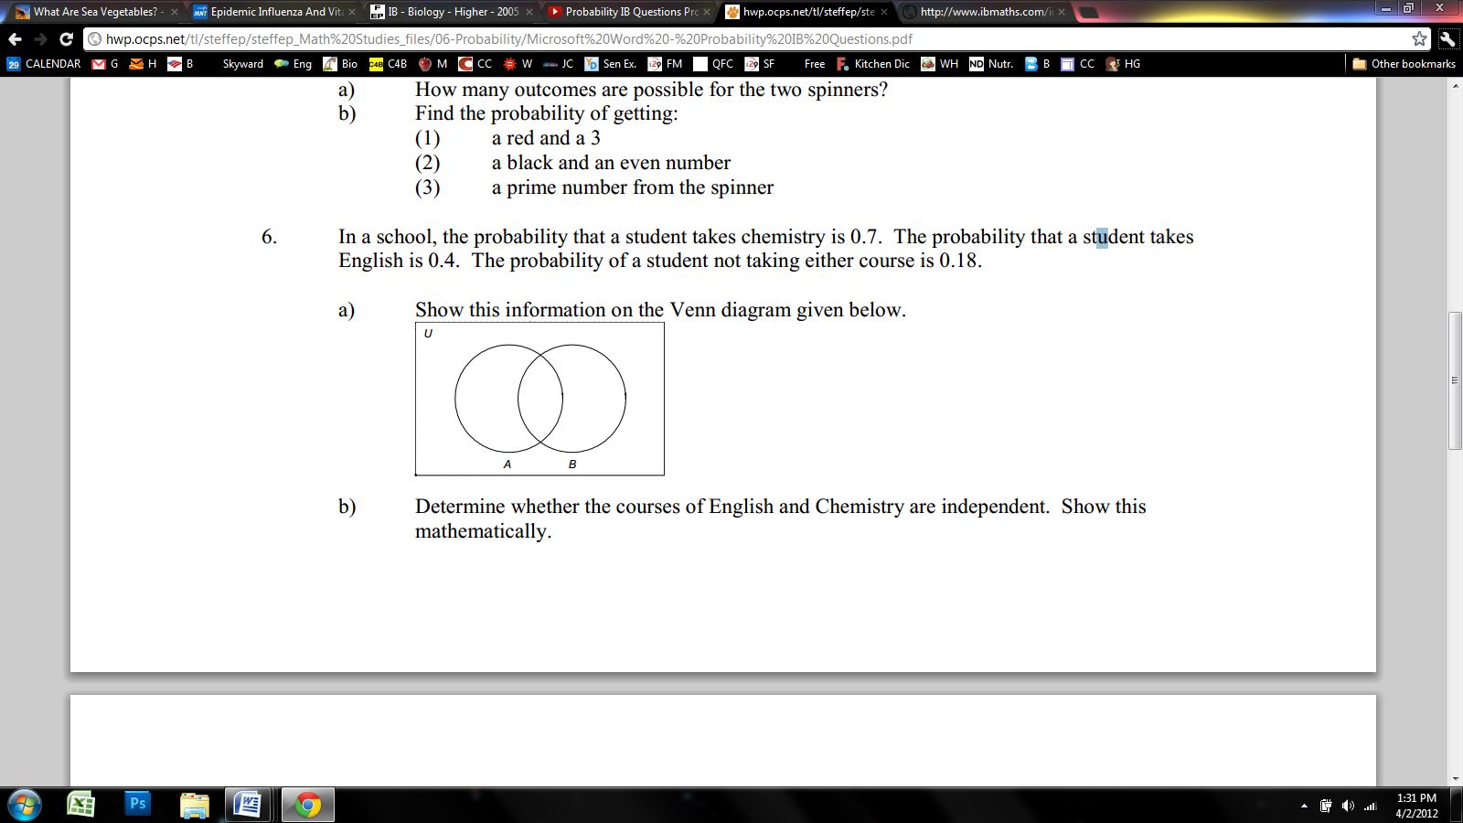

b) Determine whether the courses of IB math and IB Chemistry are independent. Show this mathematically.

7. Given that P(A)=0.6, P(B)=0.4 and that A and B are independent events. Find the probability the events

a)  d) 

c) 

1. Given that, , and, find. Demonstrate how you reached the answer.
2. Find  if the coefficient of  in the expansion of  is -112640.