IB math HL1: Curve Analysis (IB Questions)-Chapter 19 Name: _______________
You will see similar questions in the chapter 19 exam.
1 | 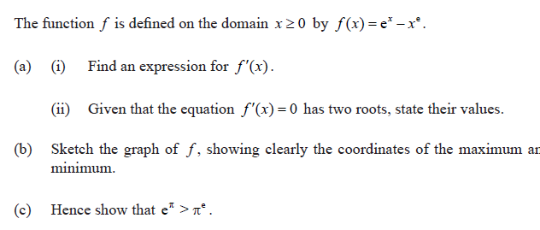
2 | 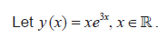  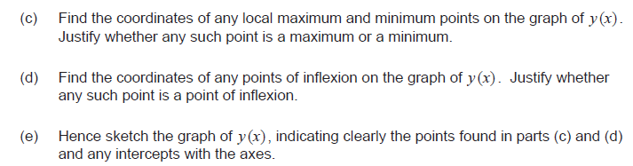
3 | 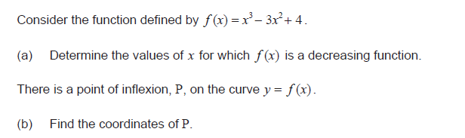
4 | Use Calculator  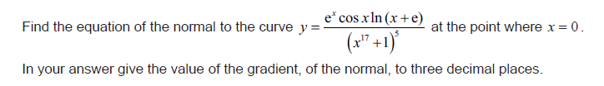
5 | 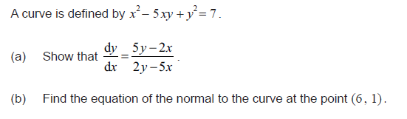
6 | 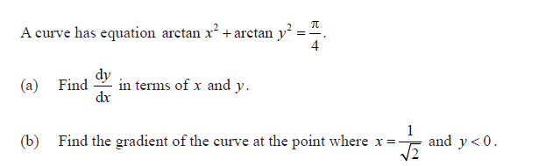
7 | 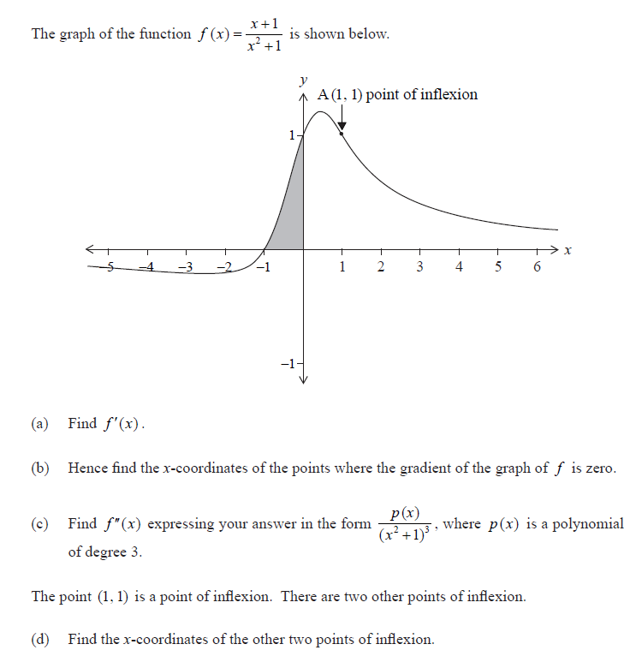
8 | Use Calculator  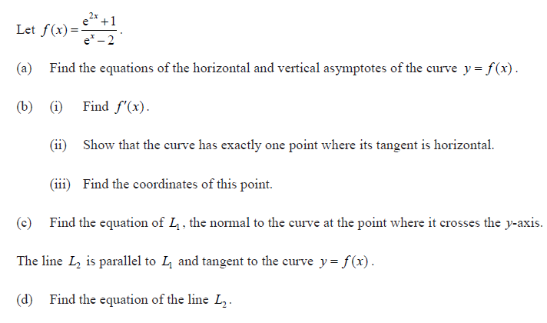
9 | 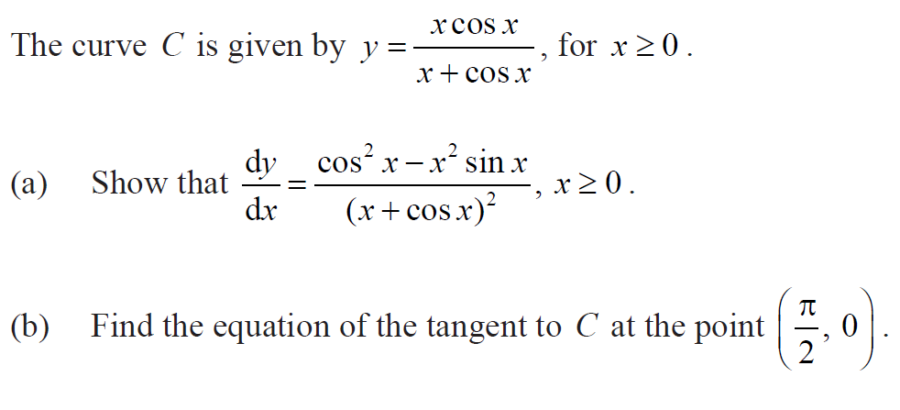

11 | 