**IB Pre HL: Binomial Theorem Name: _______________**

**Warm up:**

**Expand** 

General term in the Binomial Expansion: 

Example 1) What is the coefficient of  in ?

Example 2) In the expansion of  find the constant term.

Example 3) Find the coefficient of  in the expansion of .

Practice)

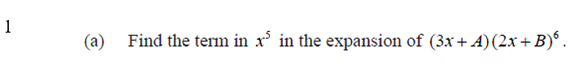

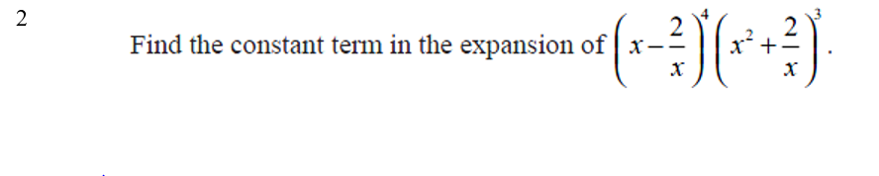

|  |  |
| --- | --- |
|  |  |
|  |  |
| 3 |  |