IB Pre HL: Chapter 6 IB Questions
1 | 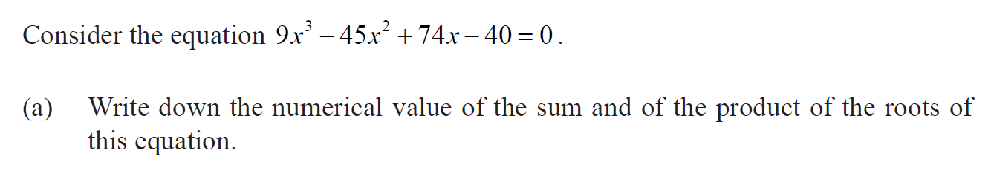
2 | 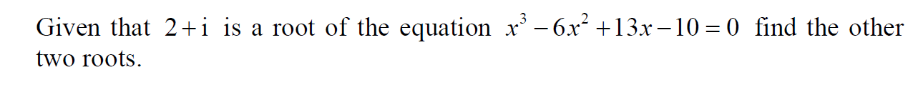
3
4 | 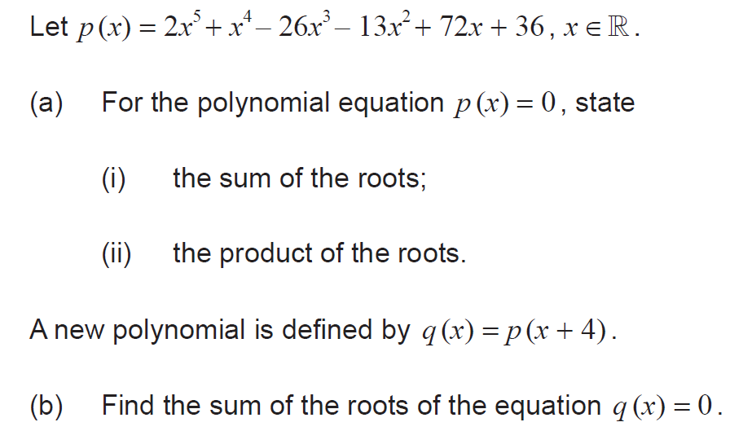
5
6 | 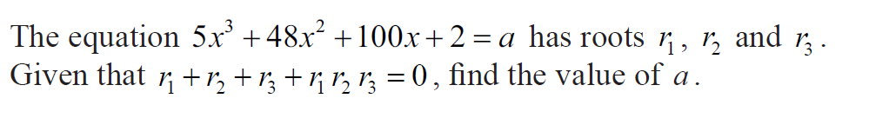
7 | 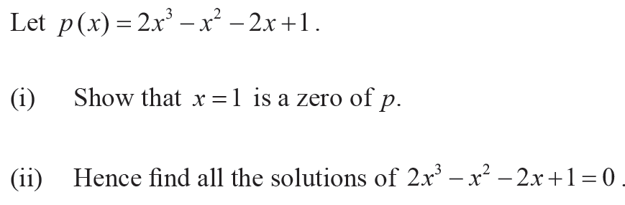
8
9 | 