**IB Pre HL: Ch 24 Exit slip and IB questions Name: ________________________**

Calculator is allowed.

1. In a promotion to try to increase the sales of a particular brand of breakfast cereal, a picture of a soccer player is put in each packet. There are ten different pictures available. Each picture is equally likely to be found in any packet of breakfast cereal. Charlotte buys four packets of breakfast cereal.
   1. Find the probability that the four pictures in these packets are all different.
   2. Of the ten players whose pictures are in the packets, her favorites are Alan and Bob.
   3. Find the probability that she finds at least one picture of a favorite player in these four packets.
2. A box containing 20 chocolates, of which 15 have soft centres and 5 have hard centres. Two chocolates are taken at random, one after the other. Calculate the probability that both chocolates have hard centres, given that the second chocolate has a hard center.
3. Three Mathematics books, five English books, four Science books and a dictionary are to be placed on a student’s shelf so that the books of each subject remain together.  
   (a) In how many different ways can the books be arranged? [4 marks]  
   (b) In how many of these will the dictionary be next to the Mathematics books? [3 marks]

4. There are six boys and five girls in a school tennis club. A team of two boys and two girls will be selected to represent the school in a tennis competition.

(a) In how many different ways can the team be selected? [3 marks]

(b) Tim is the youngest boy in the club and Anna is the youngest girl. In how many different ways can the team be selected if it must include both of them? [2 marks]

(c) What is the probability that the team includes both Tim and Anna? [1 mark]

1. Vincent and Jessica play a game, by throwing a die in turn. If the die shows a 4, 5, or 6, the player who throws the die wins the game. If the die shows 1, 2, or 3 the other player has the next throw. Vincent plays first and the game continues until there is a winner.

a) What is the probability that Vincent wins the game on his *2nd* roll?

b) What is the probability that Jessica wins the game on her 2nd roll?

c) Calculate the probability that Vincent wins the game.

6. . In a school, the probability that a student takes IB chemistry is 0.4. The probability that a student takes IB math is 0.75. The probability of a student not taking either course is 0.12.

1. Show this information on the Venn diagram given below.

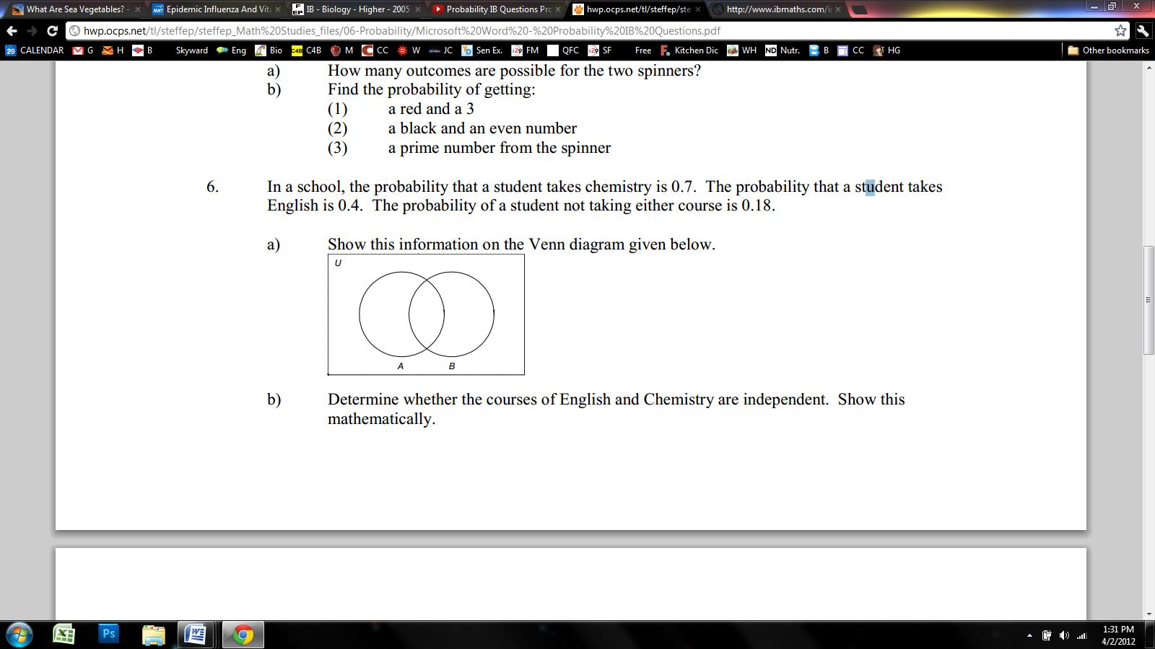

b) Determine whether the courses of IB math and IB Chemistry are independent. Show this mathematically.

1. Given that P(A)=0.6, P(B)=0.4 and that A and B are independent events. Find the probability the events

a)  d) 

c) 

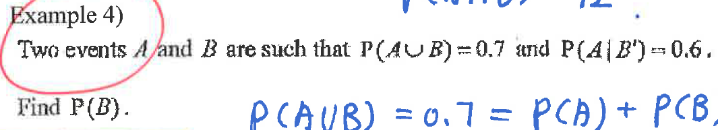

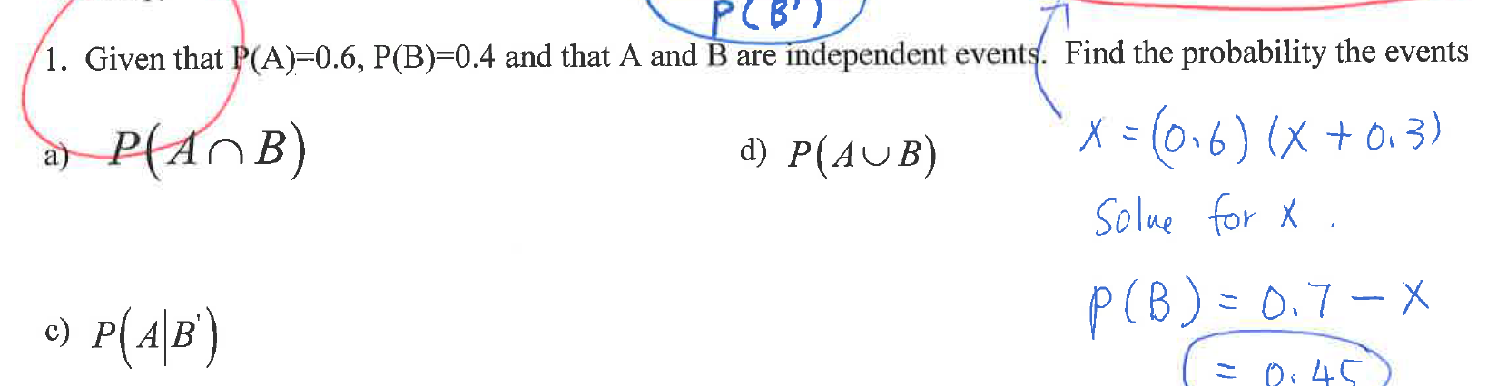

*Notes: To prepare for the exam efficiently, study all Exit questions from the notes, the two Exit slip IB questions, and review problems. Do not expect you will do fine on exam without studying.*