Integration by Parts Day 2

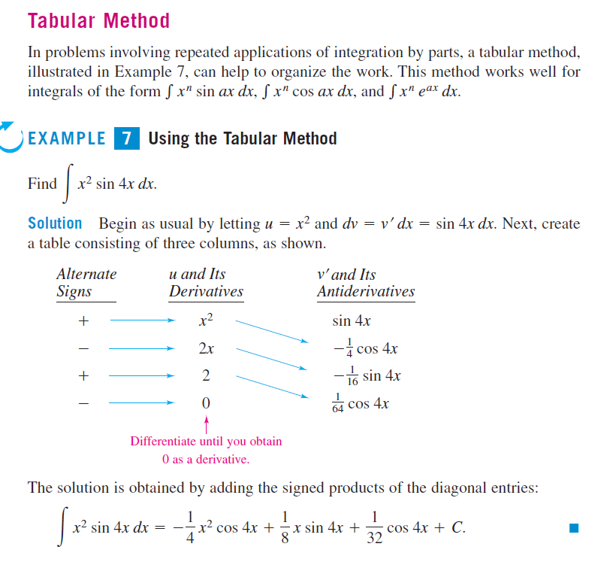

|  |  |  |
| --- | --- | --- |
| 1. Integrate  a. by parts, letting .  b. by substitution, letting . | 2. Integrate  a. by parts, letting .  b. by substitution, letting . |  |

3. Integrate  by parts. It will be necessary to repeat the process.

Reminder:

   

4. Integrate  by parts.

5. Evaluate each expression. Give an answer in the indicated interval.

a. ,  b. ,  c. , 

|  |  |  |
| --- | --- | --- |
| Practice WS 1)  1. Integrate  a. by parts, letting .  b. by substitution, letting . | 2. Integrate  a. by parts, letting .  b. by substitution, letting . |  |

3. Integrate  by parts. It will be necessary to repeat the process.

Reminder:

   

4. Integrate  by parts.

5. Evaluate each expression. Give an answer in the indicated interval.

a. ,  b. ,  c. , 

Practice WS 2)

Find the integral.

1.  2.  3. 4.

5. 6.  7.  8. 

**If you want a challenge**: evaluate the integral using substitution first, then using integration by parts.

9.  [Hint: , rewrite the integral in terms of w. 10.