**IB Math SL Syllabus concepts so far**

**ALGEBRA**

Arithmetic Sequences & Series

Geometric Sequences & Series

Sigma Notation

Exponents & logarithms

Exponent Laws

Log Laws

Binomial Theorem

**FUNCTIONS & EQUATIONS**

Domain & Range of Functions

Composition of Functions

Inverse Functions

Characteristics of Graphs (max/mins, intercepts, asymptotes, etc)

Reciprocal Functions

Transformations of graphs (Translations, reflections, stretches & compressions)

Quadratic Functions

Polynomial Functions

Exponential Functions

Logarithm Functions

Exponential Equations

**CIRCLE FUNCTIONS & TRIGONOMETRY**

Radian measure

Arc length

Sinx, cosx, tanx

The unit circle

cos2𝜃+ sin2𝜃 = 1

Double angle identities

Graphs of sin x, cos x, tan x

Sinusoidal functions

Solving trigonometric equations graphically & analytically

Solving triangles

Sin law, including ambiguous case

Cos law

Tan law (just kidding; making sure you are still reading!)

Area of triangles (using 𝐴= ½𝑎𝑏𝑠𝑖𝑛𝐶)

**STATISTICS & PROBABILITY\***

**\*Not all these topics may have been covered before the IA.**

Concepts of outcomes, sample space, etc

The probability formula

Complimentary events

Venn diagrams

Tree diagrams

Mutually Exclusive events

Independent events (with and w/o replacement)

Concepts of population, sample, random sample, discrete vs continuous data

Frequency distribution tables and histograms

Box & whisker plots, with outliers

Concept of grouped data; interval width, upper & lower boundaries, etc

Statistical measure and their interpretations

Measure of central tendency (mean, median, mode)

Quartiles & percentiles

Measures of dispersion; range, IQR, standard deviation

Cumulative frequency graphs (Ogives)

Linear coefficient of bivariate data

Pearson’s coefficient

Scatter diagrams and line of best fit

Regression equations

Probability distributions

Expected Value

Binomial Distribution; including mean and variance

Normal distribution

Z-scores

**Math Technology Resources**

[www.geogebra.org](http://www.geogebra.org) Great software for working with graphs, diagrams, functions, spreadsheets, statistics, calculus and much, much more.

<http://www.khanacademy.org/> Fabulous resource for quick tutorial on many math topics. Use the search feature to find videos, applets, and notes to help you understand some of the math behind your topic.

[www.fooplot.com](http://www.fooplot.com) An online graph plotter with graphing capabilities similar to those of your graphical calculators.

[www.wolframalpha.com](http://www.wolframalpha.com) A really powerful search (For example, type “find antiderivative of f(x) = 3x” into the search bar.) There is an app available for iphones, etc.

Not sure how to do something? You tube is a great source of tutorial videos. For example, here is a video on how to create a graph using Excel. <http://www.youtube.com/watch?v=oZAZj7NIkic>

Word has an equation editor built in – this will make your life easier when it comes to word processing mathematics. You may need to install this feature. There are youtube videos and various websites that show you have to use the editor.

<http://calculator.runiter.com/graphing-calculator/> Graphing Calculator 3D: A free program that can graph in three dimensions. Can be downloaded or used online

**POSSIBLE IA STIMULI**

Math  
Violin  
High school  
Biking  
Infinity  
Basketball  
Planes  
Trains  
Cars  
Skydiving  
Money   
Football  
Hamster  
Explosion  
Frisbee  
Soccer  
Investments  
Music  
Robotics   
Space  
Sports  
Physics  
Computer  
Videogames   
Traveling  
Cats  
Cooking   
Business  
Engineering  
Investment  
Programing  
Jetskiing

Basketball

Swimming

Soccer

Rocketry

Games

Technology

Investments

Baseball

Hiking

Cars

Flying planes

Baking

Music

Photovoltaic Wasps

Traveling

Cards

Space

Smiles

Working out

Starbucks

Hockey

Global warming

Population

Motorcycles

Model trains

Clocks

Car reliability

Star Trek (original)

Tennis

Biking

Ice Cream

Running

Skydiving

BMWS

Baseball

Guitar

Debt

Card Games

Rock Climbing

Bowling

Travel

Suntanning

Coffee

Book Publishing

Sewing

Road trips

Dog racing

Ecology

Shopping

Birding

Space travel

Camping

Mortgages

$1 000 000

Reading

Airplanes

Piano

Fishing

Swimming

Running

Biking

Skiing

Golf

Costuming

Puzzles

Exploring

Baseball

Fishing

Cooking

Volleyball

The beach

Investing

Quilting

Baking

Cake decorating

Remodelling

Gardening

Finances

Earthquakes

Income

Cards

Shotput

Lighting & Stage

Sabermetrics

Bridges

Soccer

Golden ratio

Music

Basketball

Crowd sourcing

Social networking

Drug/alcohol testing

Girls vs Boys

Political polling

Cooking

Finance

Video Games

Sports Stats

CSI

College costs

Art

Immigration Issues

The stock market

Tangrams

The Abacus

Anthropology

Matrices

Imaginary numbers

Binary number systems

Carnival games

Quipus

Navajo blankets

Sudokus

Fermat’s last theorem

Bar codes

The enigma Machine

The Rosetta stone

Cryptography in war

Cryptography in computer

Email and data transferring

Credit/debit cards

Poetry

Acoustics

Kaleidoscopes

Da Vinci

Platonic solids

Roman architecture

Labyrinths

Mixing colours

One point perspective drawing

Octaves, tuning, and pitch

The shapes of instruments and how this affects their sound

Fractals as art

String art

Drumming

Advertising

DNA

Population growth

Energy conservation

Wireless technology

Shrinking forests

Aerodynamics

Recycling

Computer programming

Construction

Topography

Topology

Body Mass Index

Skateboarding

Earth day

Agriculture

Roller coasters

Computer game design

Immunology

Oceanography

Chaos theory

Queuing theory

Projectiles

Paper airplanes

Rockets

GPS

Bicycles

Baseball

Cars

Religion

Sailing

Meteorology

Game theory

Maps

**A possible mind map for the stimulus “water”**

During introductory discussions about the exploration, the use of brainstorming sessions can be useful to generate ideas. In particular, the use of a mind map has been shown to be useful in helping students to generate thoughts on this. The mind map below illustrates how, starting with the stimulus “water”, some possible foci for a mathematical exploration could be generated.

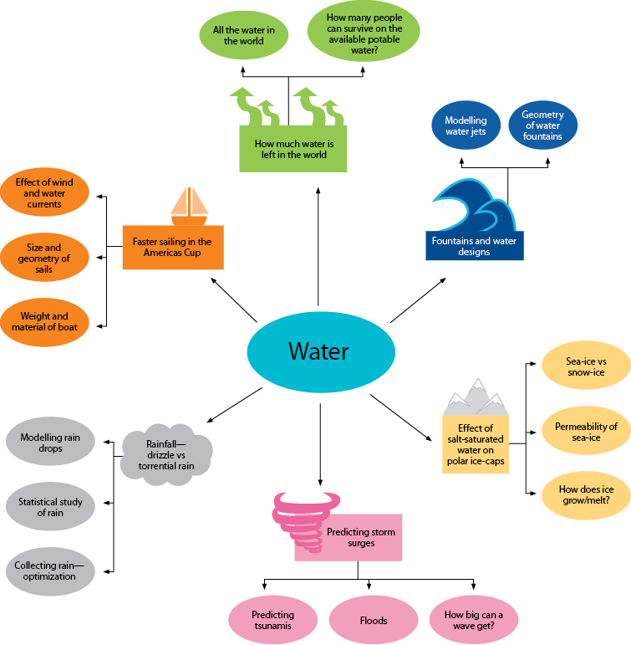

**Hints and Tips** to writing a good Math Exploration

* Start with an introduction that includes your research question.
* Then state your aim and rationale.

Aim: What is the point of your exploration?

Rationale: Why did you choose this topic? What do you hope your reader will learn?

* Create an outline to help you organize your ideas and streamline your research.
* While doing your research, keep a record of each website you visited and include the date.
* If you need to round any decimal, consider the degree of accuracy. For your topic, how many decimal places are relevant? For example, while a difference of one tenth may not matter if you are talking about speed of a locomotive, it could matter if you are talking about the amount of milligrams of morphine administered to a patient.
* Use ≈ for any rounded values.
* Include page numbers for easier reference later on.
* Only use mathematics that YOU understand. Khan Academy or YouTube could help. If you still can’t figure it out, it’s probably too hard for this level of math. It is not your teacher’s responsibility to teach you the math.
* Ask and answer personal questions (“I wonder if…, What if…)?. Make conjectures (an opinion or theory without sufficient evidence or proof).
* Use proper math vocabulary (~~plug in~~ →substitute) and notation (~~x^2~~ →x2). Use Equation Editor or similar for mathematical expressions and equations.
* Consider the historical and global perspectives of your topic.

Historical perspective: things that have happened with your topic in the past

Global perspective: the links between your own life and others throughout the world

* Discuss the implications of your results. (What do they mean? Why are they important? How do they affect your life?...)
* Discuss your results in the context of your topic, not just in general terms.

Ex:

*~~The graph levels off at x > 15~~*

*The graph levels off after the age of 15 because that is the average age when girls tend to reach their maximum height.*

* Discuss possible limitations and/or extensions of your topic.

Limitation: a restriction, a defect or failing

Extension: an occurrence in another area

* Make connections between your topic and different disciplines and/or areas of mathematics?
* Add “your voice” to your paper.