**Internal assessment type II : Modeling Functional building - Answer Key**

**Introduction:**

I have been tasked with designing an office block that fits inside a curved a roof structure. I have been giving these specifications:

The building has a rectangular base 150 m long and 72 m wide. The maximum height of the structure should not exceed 75 % of its width for stability or be less than half the width for aesthetic purposes. The minimum height of a room in a public building is 2.5 m.

Two pictures of a roof structure have been given to me and the roof structure I use should be similar to these pictures. The pictures show what appears to be a right parabolic cylinder where the width of the parabola where it intersects with the ground is less than the length of the building. There is no specific requirement that the curve of the facade must be a parabola so different curves will be investigated.

As the building underneath the roof structure is an office block, one of the most important end goals is to have a large amount of floor area. In order to achieve this goal, I will focus on maximizing volume and then use the dimensions that produce these volumes to evaluate the floor area. Another important goal is to keep the ratio of building volume to total structure volume as high as possible to minimize the volume of wasted space between the building and structure. Equally, if the only interest was in maximizing floor area, the office building wouldn't be constructed under a curved structure. Therefore aesthetics remain an important consideration and should not be ignored.

The minimum height of a room is 2.5 meters. However, this does not mean that a building with a height of 15 meters can have 6 stories. Space needs to be left between the 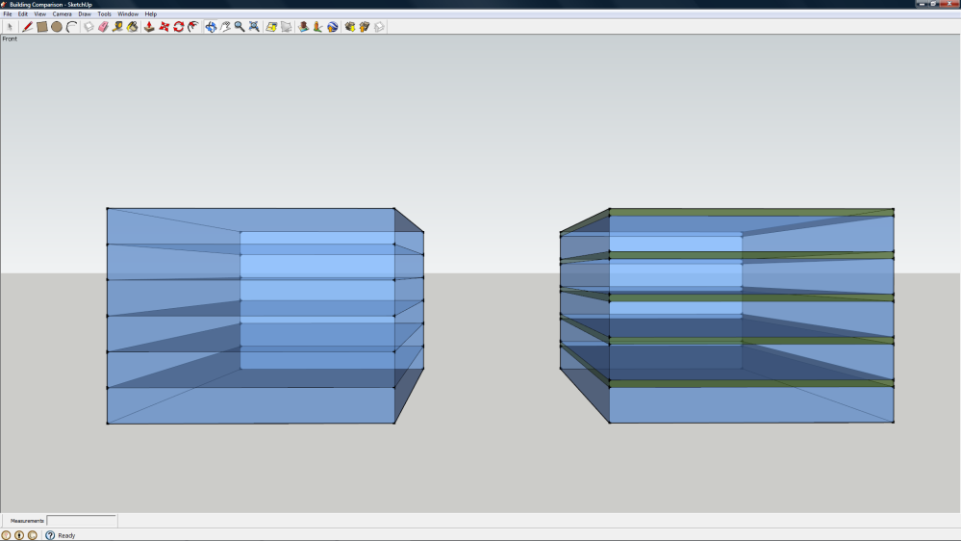ceiling of one story and the floor of the next for the construction of the floor things such as wiring, air ducts, and plumbing. I am going to estimate the space needed for this at 0.5 meters which means that the distance from the floor of one story to the floor of the next story is 3 meters. This additional space is also needed above the top floor for construction of the roof. This would mean the 15 meter high building can only have 5 stories, not 6.

This diagram shows the difference between a building that does not account for the space between stories and one that does.

Initially, the investigation will focus on an office block constructed as a single cuboid, but in the interest of maximizing volume and office area, multiple cuboids will be considered later.

All 3-D models in this paper were created with SketchUp from Google. All 2-D models were created with Geometer's Sketchpad from KCP Technologies. The only graph was created with LoggerPro from Vernier Software.

**A Roof Structure with a Height of 36 Meters:**

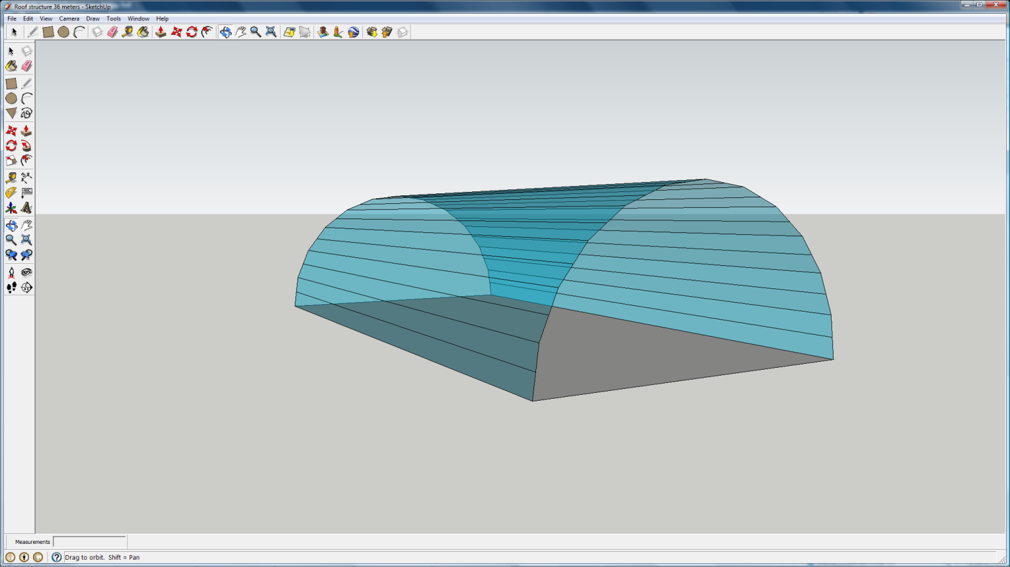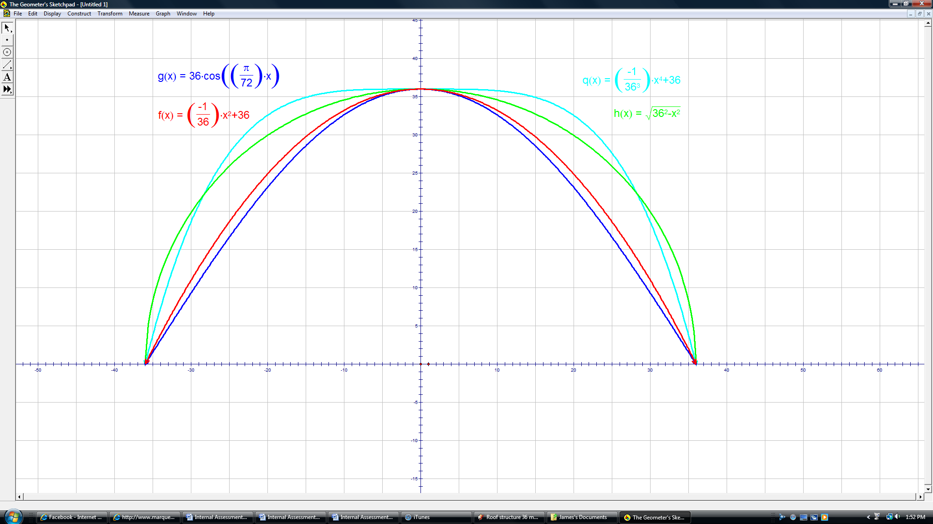 There are multiple equations that could be used to model the curve of the facade. It could be a polynomial, an ellipse, or even part of a sinusoid. The diagram at right shows the roof structure with a height of 36 meters, a width of 72 meters, and a length of 150 meters. The curve on this diagram is a semicircle, but it could be any of the other curves. To examine other possible shapes for the facade, I have plotted four functions: a cosine graph, a semicircle (a special form an ellipse), a quadratic graph, and a quartic graph. The equations are written in the same color that the graphs are plotted. Each equation was created so that it would contain the points (-36, 0), (0,36), and (36,0) to give the appropriate height and width. See Table 1 for more detail.

|  |  |  |  |
| --- | --- | --- | --- |
| Table 1: Developing the equations of the curves of the facade. | | | |
| $$y=-ax^{2}+c$$ | $$y=-ax^{4}+E$$ | $$\frac{x^{2}}{a^{2}}+\frac{y^{2}}{b^{2}}=1$$ | $$y=A\cos{\frac{2π}{B}x}$$ |
| $$36=-a{(0)}^{2}+c$$ | $$36=-a{(0)}^{4}+E$$ | $$\frac{x^{2}}{{36}^{2}}+\frac{y^{2}}{{36}^{2}}=1$$ | $$y=36\cos{\frac{2π}{144}x}$$ |
| $$36=c$$ | $$36=E$$ | $$\frac{y^{2}}{{36}^{2}}=1-\frac{x^{2}}{{36}^{2}}$$ | $$y=36\cos{\frac{π}{72}x}$$ |
| $0=-a{(36)}^{2}$ +36 | $0=-a{(36)}^{4}$ +36 | $$y^{2}={36}^{2}-x^{2}$$ |  |
| $$a=\frac{1}{36}$$ | $$a=\frac{1}{{36}^{3}}$$ | $$y=\sqrt{{36}^{2}-x^{2}}$$ |  |
| $$y=\frac{-1}{36}x^{2}+36$$ | $$y=\frac{-1}{{36}^{3}}x^{4}+36$$ |  |  |

The volume of a cuboid is found by multiplying the length by the width by the height. The length is a constant 150 meters for every curve, so the values of interest are the values for the length and the height of the cuboid that gives the maximum area. To find these values will require developing an equation for the area and taking the derivative in order to optimize it.

I will create an equation for the area in the first quadrant by defining the width as *x* and the height as the equation of the function. I will then take the derivative and set it equal to zero to find the width that gives the maximum area. I will input that value into the equation for the curve to find the height. I will then multiply the width found through optimization by two to account for the other half of the building in the second quadrant. I will show this process for the quadratic equation here, but will show the work for the other equations in Appendix A. An important thing to remember is that the cosine equation cannot be optimized algebraically as the variable is both outside and inside the cosine function. Values using the cosine equation will therefore be approximated graphically.

Area equation for quadratic curve:

$$A=x\left(\frac{-1}{36}x^{2}+36\right)$$

$$A=\left(\frac{-1}{36}x^{3}+36x\right)$$

Derive:

$$A'=\frac{-3}{36}x^{2}+36$$

Set equal to zero and solve:

$$\frac{-3}{36}x^{2}+36=0$$

$$36=\frac{3}{36}x^{2}$$

$$\frac{{36}^{2}}{3}=x^{2}$$

$$\frac{36}{\sqrt{3}}=x$$

$$12\sqrt{3}=x$$

Solve for height (I am using a less simplified value for x to make the math easier):

$$H=\left(\frac{-1}{36}x^{2}+36\right)$$

$$H=\left(\frac{-1}{36}{(\frac{36}{\sqrt{3}})}^{2}+36\right)$$

$$H=\frac{-36}{3}+36$$

$$H=24$$

Doubling $12\sqrt{3}$ gives the final width of $24\sqrt{3}$ meters. This width multiplied by a height of 24 meters gives the maximum area for a rectangle inscribed in this curve. This area is $576\sqrt{3}$ square meters. The total area under the curve is equivalent to:

$$\int_{-36}^{36}{\frac{-1}{36}x^{2}+36}dx$$

Using my TI-84 Plus graphing calculator to evaluate the integral, the area is 1728 square meters. The ratio of used area to total area is $576\sqrt{3}$**:** 1728 which simplifies to $\frac{\sqrt{3}}{3}$:1 or about 57.7%.

The following table displays the results of completing the process for each of the four equations (the other three are shown in Appendix A to avoid repeating the same process over and over again):

|  |  |  |  |  |  |  |  |  |  |  |
| --- | --- | --- | --- | --- | --- | --- | --- | --- | --- | --- |
| Table 2: Optimized Area and ratio of possible space used for the 4 Equations | | | | | | | | | | |
| Equation of curve | Optimized Width (m) | | Optimized Height (m) | | Optimized Area (m2) | | Total possible Area (m2) | | Ratio of used space to total space | |
| $$\left(\frac{-1}{36}x^{2}+36\right)$$ | $$24\sqrt{3}$$ | ($≈41.6$) | $$24$$ | | $$576\sqrt{3}$$ | ($≈998$) | $$1728$$ | | $$\frac{\sqrt{3}}{3}:1$$ | ($≈57.7\%$) |
| $$\left(\frac{-1}{{36}^{3}}x^{4}+36\right)$$ | $$\frac{72}{\sqrt[4]{5}}$$ | ($≈48.1$) | $$28.8$$ | | $$\frac{2073.6}{\sqrt[4]{5}}$$ | ($≈1390$) | $$2073.6$$ | | $$\frac{1}{\sqrt[4]{5}}:1$$ | ($≈66.9\%$) |
| $$36\cos{\frac{π}{72}x}$$ | $$≈38.4$$ | | $$≈23.5$$ | | $$≈926$$ | | $$≈1650$$ | | $$≈56.1\%$$ | |
| $$\sqrt{{36}^{2}-x^{2}}$$ | $$36\sqrt{2}$$ | ($≈50.9$) | $$18\sqrt{2}$$ | ($≈25.5$) | $$1296$$ | | $$648π$$ | ($≈2040$) | $$\frac{2}{π}:1$$ | ($≈63.7\%$) |

After these calculations, **it is possible to eliminate the cosine equation**. Not only does it give a significantly lower area, it also has more wasted space than the other equations. However, it is not just as simple as picking the curve that allows for the most area. If the contractor wanted a building that allowed for the most office space, they would build the office block under a roof with a facade that looks like a rectangle. In fact, increasing the power of the polynomial expressions by two as in $X^{2}, X^{4}, X^{6}…X^{2n-2}, X^{2n}$ would eventually produce a rectangular roof:

$$\lim_{n→∞}{\frac{-1}{{36}^{2n-1}}x^{2n}+36}$$

As each successive value of *n* is evaluated, the shape bounded by the graph and the x-axis becomes closer and closer to a rectangle. The quartic equation already has a much flatter top than the roof that my is supposed to resemble**. I am going to eliminate the quartic equation and any other equations with a higher power from consideration** as they are not similar enough to the roof structure that the building is based on. I am going to keep considering the quadratic equation because its shape appears to be the closest match to the roof in the picture. I am also keeping the elliptical equation as the volume is greater than the quadratic roof and because the discrepancy from the given roof is not that significant. The dimensions of the cuboid with the maximum volume are approximately:

**41.6 m by 24 m by 150 m for the quadratic facade and 50.9 m by 25.5 m by 150 m for the elliptical facade. The volumes are approximately 150,000 m3 and 195,000 m3 respectively.**

**A Roof Structure with a Variable Height:**

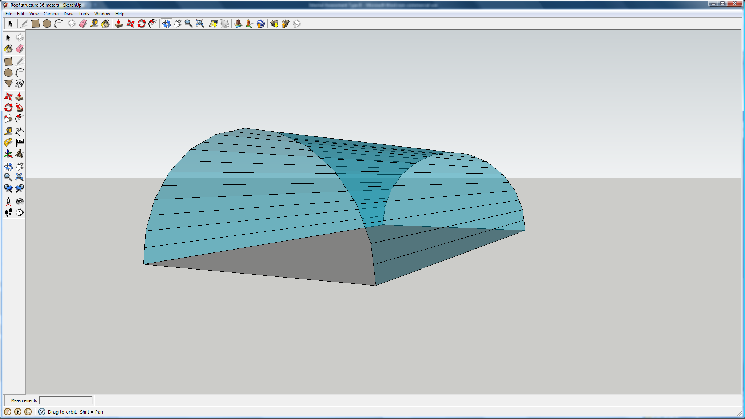 The specifications state that the height of the roof structure must be inclusively between 50% and 75% of the width. The width of the structure is 72 meters so the height can vary between 36 meters and 54 meters. The diagram at left shows a similar building to the one investigated before but the height is now 54 meters. Creating an equation to represent the area is more difficult now as the height now has to be taken into account as a variable, rather than a given number. However, before creating an equation that will cover all heights, I will investigate what happens if the height is set to 54 meters.

The new equations must go through the points (-36,0), (0,54), and (36,0). The quadratic equation that achieves this is $y=\frac{-54}{{36}^{2}}x^{2}+54$ which simplifies to $y=\frac{-1}{24}x^{2}+54$. The elliptical equation is $y=\sqrt{{54}^{2}-\frac{{54}^{2}}{{36}^{2}}x^{2}}$ which simplifies to $y=\sqrt{{54}^{2}-2.25x^{2}}$. Using the same process as before, I will optimize the area and investigate the new volume and ratio of wasted space to office space. This time I will show the mathematics with the ellipse equation but the mathematics for the quadratic equation can be found in Appendix B.

Area equation for the elliptical curve:

$$A=x\sqrt{{54}^{2}-2.25x^{2}}$$

Derive using power rule:

$$A'=\sqrt{{54}^{2}-2.25x^{2}}+\frac{x\left(-4.5x\right)\left(\frac{1}{2}\right)}{\sqrt{{54}^{2}-2.25x^{2}}}$$

Simplify:

$$A^{'}=\sqrt{{54}^{2}-2.25x^{2}}-\frac{2.25x^{2}}{\sqrt{{54}^{2}-2.25x^{2}}}$$

Set equal to zero and solve:

$$0=\sqrt{{54}^{2}-2.25x^{2}}-\frac{{2.25x}^{2}}{\sqrt{{54}^{2}-2.25x^{2}}}$$

$$\frac{{2.25x}^{2}}{\sqrt{{54}^{2}-2.25x^{2}}}=\sqrt{{54}^{2}-2.25x^{2}}$$

$${2.25x}^{2}={54}^{2}-2.25x^{2}$$

$$4.5x^{2}={54}^{2}$$

$$x^{2}=\frac{{54}^{2}}{4.5}$$

$$x=\frac{54}{\sqrt{4.5}}$$

$$x=\frac{54}{1.5\sqrt{2}}$$

$$x=\frac{36}{\sqrt{2}}$$

$$x=18\sqrt{2}$$

Solve for height (I am using a less simplified value of x to substitute in to make the calculation easier):

$$H=\sqrt{{54}^{2}-2.25x^{2}}$$

$$H=\sqrt{{54}^{2}-2.25{\left(\frac{54}{\sqrt{4.5}}\right)}^{2}}$$

$$H=\sqrt{{54}^{2}-2.25\left(\frac{{54}^{2}}{4.5}\right)}$$

$$H=\sqrt{{54}^{2}\left(1-\frac{1}{2}\right)}$$

$$H=54\sqrt{\frac{1}{2}}$$

$$H=\frac{54}{\sqrt{2}}$$

$$H=27\sqrt{2}$$

Doubling $18\sqrt{2}$ gives a final width of $36\sqrt{2}$. Multiplying the width by the height gives an area of m2. The total possible area is equivalent to:

$$\int_{-36}^{36}{\sqrt{{54}^{2}-2.25x^{2}}} dx$$

Using my graphing calculator to evaluate the definite integral, the area is equal to 972π. The ratio of the area of wasted space to the area of office block (this ratio is the same for volume as well) is $972π-1944:1944$ which is equivalent to $\frac{π}{2}-1:1$. Interestingly, the optimized width is still the same and the height is also very similar. When the roof was 36 meters high, the optimized height was $\frac{36}{\sqrt{2}}$ ($18\sqrt{2}$) meters; now that the roof is 54 meters high, the optimized height is $\frac{54}{\sqrt{2}}$ ($27\sqrt{2}$) meters.

Similarities exist with the quadratic equation as well (math shown in Appendix B). The optimized width is still $24\sqrt{3}$ and the optimized height has increased with the same ratio as the elliptical roof. As the height of the roof increased by 150% from 36 m to 54 m, the optimized height also increased by 150% from 24 m to 36 m. The ratio of wasted space to space used by the office block is $\sqrt{3}-1:1$.

With these similarities noted, I am going to use technology to show how the height affects the dimensions of the largest possible cuboid and the ratio of wasted space to total possible space. Each of the curves defining the building can be defined by $y=\frac{-h}{{36}^{2}}x^{2}+h$ and $y=\sqrt{h^{2}-\frac{h^{2}}{{36}^{2}}x^{2}}$. The area of the face of the cuboid is shown by $A=\frac{-h}{{36}^{2}}x^{3}+hx$ and $A=x\sqrt{h^{2}-\frac{h^{2}}{{36}^{2}}x^{2}}$. Using WolframAlpha, an online computational knowledge engine, I can easily and quickly derive and optimize for each height of the structure. A limitation of technology is that it sometimes uses a decimal approximation rather than an exact value such as $\sqrt{5}$ or π. In these situations, I will use my prior knowledge to determine what the exact answer should be by dividing the approximation by the approximation for the irrational number I know the exact answer should contain. This division will give me the exact answer. The first table contains the data for the quadratic curve.

|  |  |  |  |  |  |  |  |  |
| --- | --- | --- | --- | --- | --- | --- | --- | --- |
| Table 3: Using technology to evaluate the effects of changing height. | | | | | | | | |
| Height of Roof (m) | Optimized Width (m) | Optimized Height (m) | Optimized Area (m2) | Total Possible Area (m2) | Ratio of Wasted Space to Used Space | | Length (m) | Volume (m3) |
| 36 |  |  |  |  |  | () |  |  |
| 37 |  |  |  |  |  | () |  |  |
| 38 | $$24\sqrt{3}$$ | $$\frac{76}{3}$$ | $$608\sqrt{3}$$ | $$1824$$ | $$\sqrt{3}-1:1$$ | ($≈73.2\%$) | $$150$$ | $$91200\sqrt{3}$$ |
| 39 | $$24\sqrt{3}$$ | $$26$$ | $$624\sqrt{3}$$ | $$1872$$ | $$\sqrt{3}-1:1$$ | ($≈73.2\%$) | $$150$$ | $$93600\sqrt{3}$$ |
| 40 | $$24\sqrt{3}$$ | $$\frac{80}{3}$$ | $$640\sqrt{3}$$ | $$1920$$ | $$\sqrt{3}-1:1$$ | ($≈73.2\%$) | $$150$$ | $$96000\sqrt{3}$$ |
| 41 | $$24\sqrt{3}$$ | $$\frac{82}{3}$$ | $$656\sqrt{3}$$ | $$1968$$ | $$\sqrt{3}-1:1$$ | ($≈73.2\%$) | $$150$$ | $$98400\sqrt{3}$$ |
| 42 | $$24\sqrt{3}$$ | $$28$$ | $$672\sqrt{3}$$ | $$2016$$ | $$\sqrt{3}-1:1$$ | ($≈73.2\%$) | $$150$$ | $$100800\sqrt{3}$$ |
| 43 | $$24\sqrt{3}$$ | $$\frac{86}{3}$$ | $$688\sqrt{3}$$ | $$2064$$ | $$\sqrt{3}-1:1$$ | ($≈73.2\%$) | $$150$$ | $$103200\sqrt{3}$$ |
| 44 | $$24\sqrt{3}$$ | $$\frac{88}{3}$$ | $$704\sqrt{3}$$ | $$2112$$ | $$\sqrt{3}-1:1$$ | ($≈73.2\%$) | $$150$$ | $$105600\sqrt{3}$$ |
| 45 | $$24\sqrt{3}$$ | $$30$$ | $$720\sqrt{3}$$ | $$2160$$ | $$\sqrt{3}-1:1$$ | ($≈73.2\%$) | $$150$$ | $$108000\sqrt{3}$$ |
| Height of Roof (m) | Optimized Width (m) | Optimized Height (m) | Optimized Area (m2) | Total Possible Area (m2) | Ratio of Wasted Space to Total Space | | Length (m) | Volume (m3) |
| 46 |  |  |  |  |  | () |  |  |
| 47 |  |  |  |  |  | () |  |  |
| 48 | $$24\sqrt{3}$$ | $$32$$ | $$768\sqrt{3}$$ | $$2304$$ | $$\sqrt{3}-1:1$$ | ($≈73.2\%$) | $$150$$ | $$115200\sqrt{3}$$ |
| 49 | $$24\sqrt{3}$$ | $$\frac{98}{3}$$ | $$784\sqrt{3}$$ | $$2352$$ | $$\sqrt{3}-1:1$$ | ($≈73.2\%$) | $$150$$ | $$117600\sqrt{3}$$ |
| 50 | $$24\sqrt{3}$$ | $$\frac{100}{3}$$ | $$800\sqrt{3}$$ | $$2400$$ | $$\sqrt{3}-1:1$$ | ($≈73.2\%$) | $$150$$ | $$120000\sqrt{3}$$ |
| 51 | $$24\sqrt{3}$$ | $$34$$ | $$816\sqrt{3}$$ | $$2448$$ | $$\sqrt{3}-1:1$$ | ($≈73.2\%$) | $$150$$ | $$122400\sqrt{3}$$ |
| 52 | $$24\sqrt{3}$$ | $$\frac{104}{3}$$ | $$832\sqrt{3}$$ | $$2496$$ | $$\sqrt{3}-1:1$$ | ($≈73.2\%$) | $$150$$ | $$124800\sqrt{3}$$ |
| 53 | $$24\sqrt{3}$$ | $$\frac{106}{3}$$ | $$848\sqrt{3}$$ | $$2544$$ | $$\sqrt{3}-1:1$$ | ($≈73.2\%$) | $$150$$ | $$127200\sqrt{3}$$ |
| 54 | $$24\sqrt{3}$$ | $$36$$ | $$864\sqrt{3}$$ | $$2592$$ | $$\sqrt{3}-1:1$$ | ($≈73.2\%$) | $$150$$ | $$129600\sqrt{3}$$ |

As I was making this table, I noticed some important patterns and I will present them in the following table. After the table, I will show the math behind the patterns as I use the constant *h*.

|  |  |  |  |  |  |  |  |  |
| --- | --- | --- | --- | --- | --- | --- | --- | --- |
| Table 4: Patterns observed in the relationship between height and the optimal cuboid with the quadratic curve roof. | | | | | | | | |
| Height of Roof (m) | Optimized Width (m) | Optimized Height (m) | Optimized Area (m2) | Total Possible Area (m2) | Ratio of Wasted Space to Total Space | | Length (m) | Volume (m3) |
|  |  |  |  |  |  | () |  |  |

I will start with the equation for area:

$$A=\frac{-h}{{36}^{2}}x^{3}+hx$$

Derive:

$$A=\frac{-3h}{{36}^{2}}x^{2}+h$$

Set equal to zero and solve:

$$0=\frac{-3h}{{36}^{2}}x^{2}+h$$

$$\frac{3h}{{36}^{2}}x^{2}=h$$

Divide out *h*:

$$\frac{3x^{2}}{{36}^{2}}=1$$

$$x^{2}=\frac{{36}^{2}}{3}$$

$$x=\frac{36}{\sqrt{3}}$$

$$x=12\sqrt{3}$$

The height of the roof is not a factor in the optimized width of the cuboid. It does however play a role in the optimized height of the cuboid. Note that the capital *H* refers to the height of the building, while the lowercase *h* refers to the height of the roof structure.

$$H=\frac{-h}{{36}^{2}}x^{2}+h$$

$$H=\frac{-h}{{36}^{2}}{(12\sqrt{3})}^{2}+h$$

$$H=h\left(1-\frac{3\left({12}^{2}\right)}{{36}^{2}}\right)$$

$$H=h\left(1-\frac{1}{3}\right)$$

$$H=\frac{2}{3}h$$

Doubling $12\sqrt{3}$ gives the final width of $24\sqrt{3}$. Multiplying this by the height gives an area of $16h\sqrt{3}$. Integrating $\frac{-h}{{36}^{2}}x^{2}+h$ with respect to *x* from -36 to 36 will give the total possible area:

$$\int_{-36}^{36}{\frac{-h}{{36}^{2}}x^{2}+hdx}$$

$$\frac{-h}{3({36}^{2})}x^{3}+hx{ |}_{x=-36}^{x=36}$$

$$\frac{-h}{3({36}^{2})}{(36)}^{3}+h\left(36\right)-\frac{-h}{3({36}^{2})}{(-36)}^{3}-h(-36)$$

$$-12h+36h-12h+36h$$

$$48h$$

The total possible area is therefore equivalent to the height of the roof times 48. The ratio of wasted space to used space is equal to the ratio of total space minus the used space to the used space.

$$48h-16h\sqrt{3}:16h\sqrt{3}$$

The *h* cancels out leaving the constant ratio $\sqrt{3}-1:1$. The last value affected by height is volume. Volume is equivalent to the optimized area times the length of 150 meters. Since the optimized area is $16h\sqrt{3}$, the volume is equal to $2400h\sqrt{3}$.

I did the exact same process for the elliptical equation (see Appendix C for the specific math) and developed this table:

|  |  |  |  |  |  |  |  |  |
| --- | --- | --- | --- | --- | --- | --- | --- | --- |
| Table 5: Patterns observed in the relationship between height and the optimal cuboid with the elliptical curve roof. | | | | | | | | |
| Height of Roof (m) | Optimized Width (m) | Optimized Height (m) | Optimized Area (m2) | Total Possible Area (m2) | Ratio of Wasted Space to Used Space | | Length (m) | Volume (m3) |
|  |  |  |  |  |  | () |  |  |

Based on these tables, I can conclude how the height of the roof structure with a width of 72 meters and a length of 150 meters affects the dimensions of the cuboid with the maximum volume that can be contained in the roof structure. For a roof structure with a quadratic curve, the dimensions are:

$$24\sqrt{3} by \frac{2}{3}h by 150$$

For a roof structure with an elliptical curve, the dimensions are:

$$18\sqrt{2} by \frac{\sqrt{2}}{2}h by 150$$

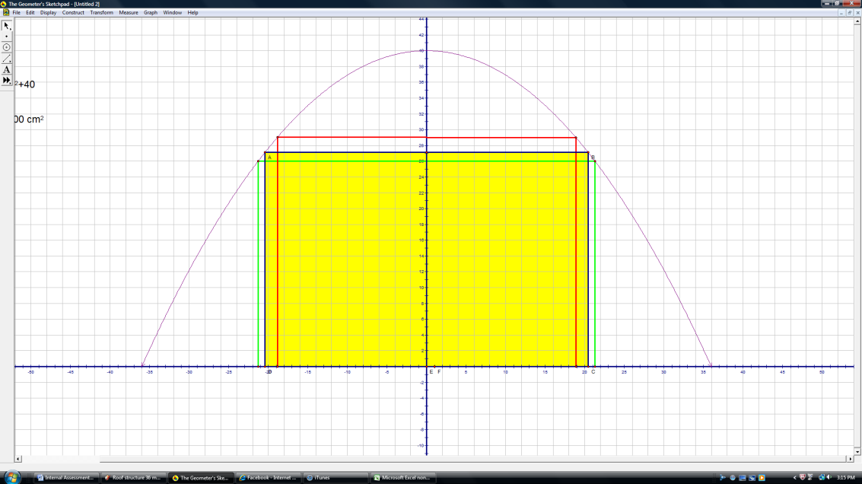 However, while these dimensions produce the maximum volume, they do not necessarily produce the greatest office area. Because each story must be 3 meters in height, having a building that is 35 meters in height may produce maximum volume, but it is inefficient as the top 2 meters cannot be used to create an additional story. Therefore, one must consider narrowing the building allowing it to be taller to create an additional floor. Floor area could also be increased by shortening the building allowing it to be wider to increase the area on each floor that already exists. Both of these approaches will be considered in the next section as I investigate the effect of height on floor area.

The yellow shows the optimized area, but the green and red outlines provide more floor area.

**Effect of Height of the Roof on Floor Area:**

I am going to create a table to show how the height of the structure and the number of stories affects the amount of available office space. As the height of the building is now an input rather than an output, I will need to rearrange the equation so that width is the output. I will also need to account for the other half of the building by multiplying by two. This new equation is:

$w=2\sqrt{\frac{{36}^{2}(h-H)}{h}}$ where *h* is height of the roof, *H* is the height of the building and *W* is the width.

The table will be made in Microsoft Excel and the values will be decimal approximations to three significant figures unless they are exact such as the height of the building or more significant figures are needed to show the difference between the floor areas for two different stories.



I have shaded in the maximum floor area for each height of the roof structure that gives the most floor area. In general, the floor area is optimized when the building height is closest to the optimized height of the building for that roof structure. For example, the optimized height for the building under a roof structure with a height of 38 meters is about 25.3 meters. The closest possible heights are 24 and 27 meters. 24 is closer to 25.3 than 27 is and it gives the most floor area. This rule is not perfect as the point at which it becomes more advantageous to jump up to 9 stories is not exactly 25.5 but is in fact a little higher. However, the value is very close so it is a good general rule in almost all situations.

I am going to create the same table for the roof with the elliptical curve. The equation for width is: $w=\frac{72}{h}\sqrt{h^{2}-H^{2}}$ where *h* is height of the roof and *H* is the height of the building.

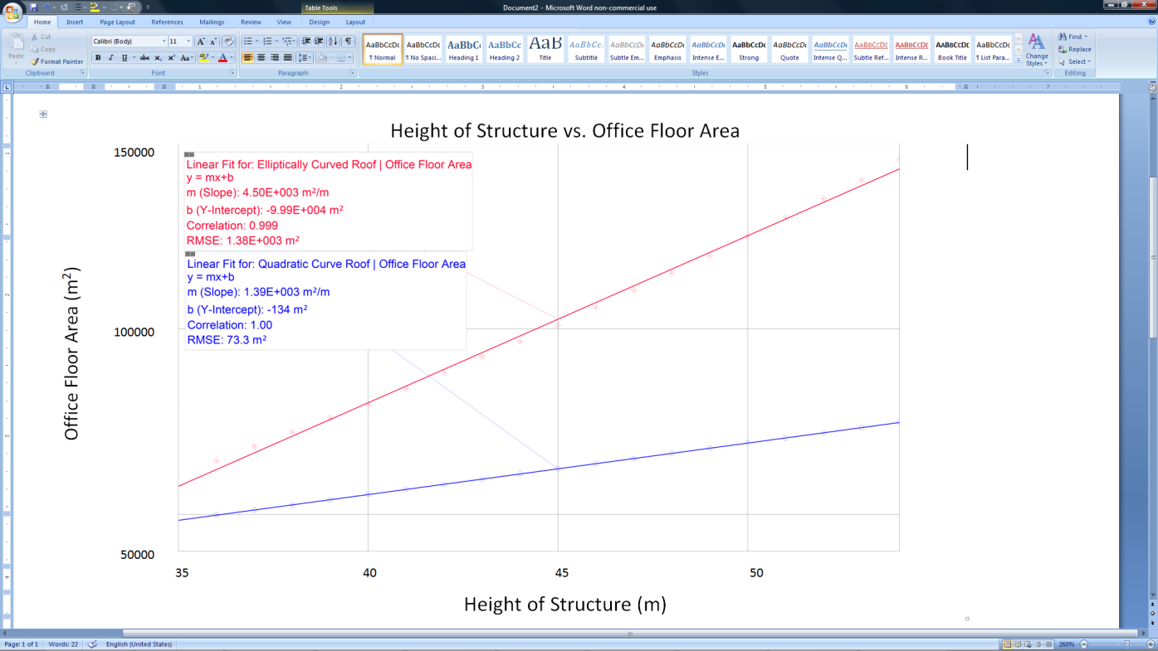 The above table shows the same pattern that the table regarding the quadratic roof did. Every height of the roof structure has an optimized height. Whichever multiple of three the optimized height was closest to determined how many levels would be needed to optimize the floor area. An interesting set of data is associated with the height 53.0 meters. For this height, the optimized height is approximately 37.5 meters but if more significant figures were shown, it would be clear that is slightly less than 37.5. However, as 37.5 is in the middle of 36 and 39, it shows how close the floor areas become at this boundary point. I had to use 5 significant figures in order to show that the floor areas for 12 stories and 13 stories were different at this height.

The graph at left plots the height of the structure against the maximum office floor area for each of the heights. The graph shows that the relationship between the height of the structure and maximum floor area is very close to being linear. It also shows that the roof structure with an elliptic curve as the facade has more office area and the increase in office area per increase in height is also greater.

**Effect of Width of Facade on Volume and Floor Area:**

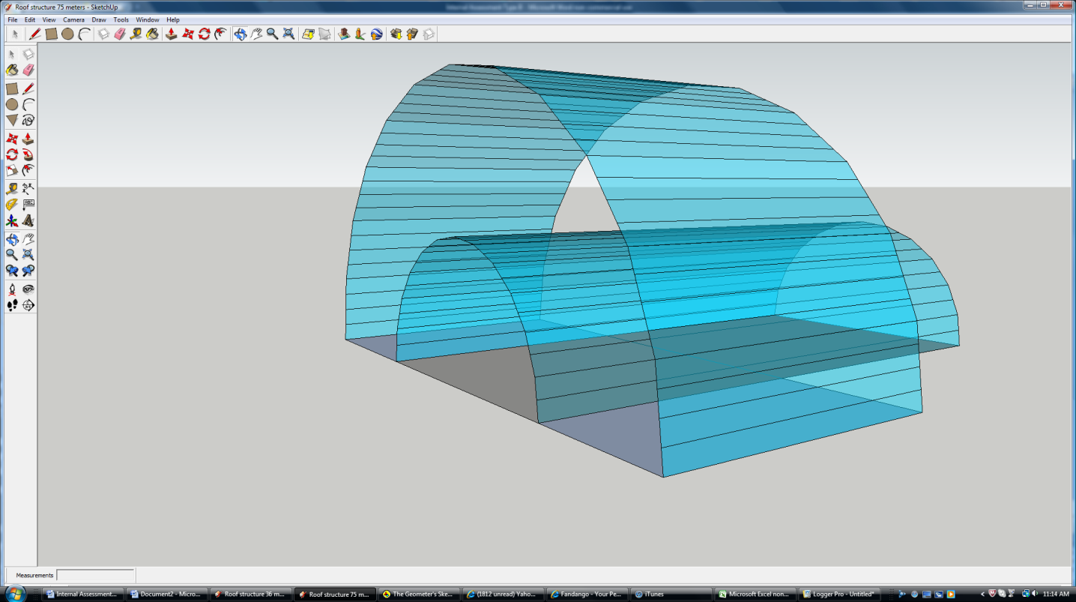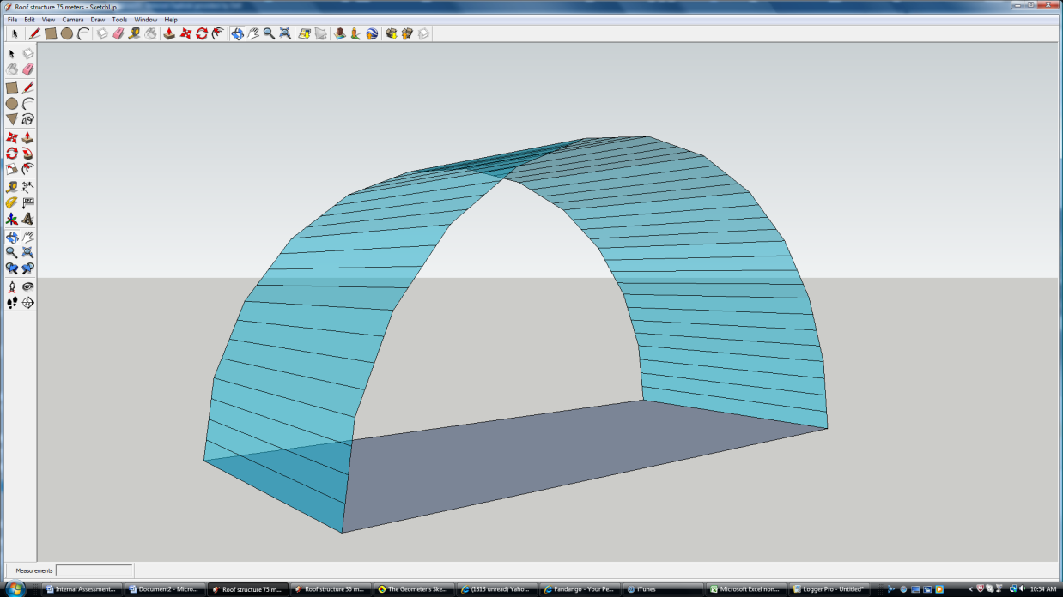 I have been asked to consider placing the facade on the longer side of the building. This would mean the width of the curve would be 150 meters as opposed to 72 meters. This also means the height has been increased as the height is restricted to values that range from 50% to 75% of the width. Before, the range was 36 meters to 54 meters. Now, the range is 75 meters to 112.5 meters. The other effect of this switch is the reduction in length. Any increases in volume due to increased width and height will be reduced by a decrease in length from 150 meters to 72 meters. I know the width of the roof structure will have an effect on the volume and consequently on floor area. After creating another model of the roof structure with these new dimensions (150 m width by 75 m height by 72 length), I think that this new roof structure will allow for more volume and floor area. I placed the first model inside the second model to allow for a better comparison and it clearly shows that the volume is much greater with the greater width. A possible issue with this design is that is significantly changes the appearance of the roof. Instead of a shorter, narrower, longer building, this structure is much wider and taller, but is shorter in length. I do not feel that the change in appearance warrants discounting this new roof structure from consideration.

One of the primary advantages of this new roof structure is that an increase in width allows an increase in height. This would allow for more stories and thus more office space. As I showed with the investigation on floor area, the elliptical roof allowed for more floor area and there was a greater increase in floor area for each additional story. As this investigation shifts towards maximizing floor area, **I am going to discount the roof with the quadratic curve.** While the quadratic roof is the closest match to the roof that my design is supposed to resemble, the elliptical roof does not vary too much from the design and the increase in floor area is a huge advantage. As I continue with my investigation, I will treat the length, the width, and the height as three constants so I can fully understand the relationships that these variables have with each other.

**Effect of Width, Height, and Length of an Elliptically Curved Roof on Volume and Floor Area:**

I am going to start by defining the equation of the ellipse in terms of height and width:

$$y=\sqrt{h^{2}-\frac{h^{2}}{{\left(\frac{w}{2}\right)}^{2}}x^{2}}$$

Simplifying:

$$y=\sqrt{h^{2}-\frac{{4h}^{2}}{w^{2}}x^{2}}$$

The expression for area is therefore:

$$A=x\sqrt{h^{2}-\frac{{4h}^{2}}{w^{2}}x^{2}}$$

Derive with respect to *x* using power rule:

$$A^{'}=\sqrt{h^{2}-\frac{{4h}^{2}}{w^{2}}x^{2}}+\frac{x\left(\frac{1}{2}\right)(-\frac{8h^{2}}{w^{2}}x)}{\sqrt{h^{2}-\frac{{4h}^{2}}{w^{2}}x^{2}}}$$

Simplifying:

$$A^{'}=\sqrt{h^{2}-\frac{{4h}^{2}}{w^{2}}x^{2}}-\frac{\frac{4h^{2}}{w^{2}}x^{2}}{\sqrt{h^{2}-\frac{{4h}^{2}}{w^{2}}x^{2}}}$$

Set equal to zero and solve:

$$0=\sqrt{h^{2}-\frac{{4h}^{2}}{w^{2}}x^{2}}-\frac{\frac{4h^{2}}{w^{2}}x^{2}}{\sqrt{h^{2}-\frac{{4h}^{2}}{w^{2}}x^{2}}}$$

$$\frac{\frac{4h^{2}}{w^{2}}x^{2}}{\sqrt{h^{2}-\frac{{4h}^{2}}{w^{2}}x^{2}}}=\sqrt{h^{2}-\frac{{4h}^{2}}{w^{2}}x^{2}}$$

$$\frac{4h^{2}}{w^{2}}x^{2}=h^{2}-\frac{{4h}^{2}}{w^{2}}x^{2}$$

$$\frac{8h^{2}}{w^{2}}x^{2}=h^{2}$$

$$x^{2}=\frac{w^{2}}{8}$$

$$x=\frac{w}{2\sqrt{2}}$$

$$x=\frac{w\sqrt{2}}{4}$$

Using this value to solve for height:

$$H=\sqrt{h^{2}-\frac{{4h}^{2}}{w^{2}}x^{2}}$$

$$H=\sqrt{h^{2}-\frac{{4h}^{2}}{w^{2}}{\left(\frac{w\sqrt{2}}{4}\right)}^{2}}$$

$$H=\sqrt{h^{2}-\frac{{4h}^{2}}{w^{2}}\left(\frac{2w^{2}}{16}\right)}$$

$$H=\sqrt{h^{2}-\frac{h^{2}}{2}}$$

$$H=\sqrt{\frac{h^{2}}{2}}$$

$$H=\frac{h\sqrt{2}}{2}$$

Doubling $\frac{w\sqrt{2}}{4}$ gives the final width of $\frac{w\sqrt{2}}{2}$. Multiplying the width by the height gives an area for the face of the facade of $\frac{wh}{2}$. Multiplying this by length of the building gives an optimized volume of:

$$V=\frac{w\left(h\right)\left(l\right)}{2}$$

Immediately, it doesn't seem obvious why interchanging the width and the length would produce a greater area. However, the height of the structure is dependent on the width. The height can vary from 50% of the width to 75% of the width. Therefore, I am going to rewrite this equation using the maximum height of $\frac{3}{4}w$:

$$V=\frac{{3w}^{2}l}{8}$$

This means the maximum volume with the switched dimensions is 607,500 m3, significantly higher than the maximum 291,600 m3 that could be used with the original dimensions.

Before, I showed that changing the height didn't affect the ratio of wasted space to total space but just because increasing the height does not increase the ratio of wasted volume to total volume does not mean that changing the width will not. I am going to investigate how the width, the height, and the length affect the total volume contained under the roof. The volume under the roof will be equivalent to one half the area of the ellipse that defines the facade multiplied by the length. The area of an ellipse is equivalent to the product of π, half the major axis, and half the minor axis. Half the major axis is the height, half the minor axis is half the width. Therefore, the equation for the total volume is:

$$V_{t}=\frac{π\left(l\right)\left(h\right)(w)}{4}$$

A comparison of the equations reveals that increasing the width does not create a greater proportion of wasted space. If the cuboid is optimized to have the most volume, the ratio of wasted volume to total volume contained by the roof remains the same no matter the height, the length, or the width of the roof. Having shown that increasing the width does not increase the ratio of wasted space to total space while it does increase both the height and the volume, it seems promising that is will produce a much higher floor area.

$V=\frac{w\left(h\right)\left(l\right)}{2}$ vs. $V_{t}=\frac{π\left(l\right)\left(h\right)(w)}{4}$

Increasing the width, the height, or the length increases both volumes by the same amount. Changing any of these values will not result in an increase in the ratio of wasted space to total space or in the ratio of wasted space to used space.

I am now going to find the maximum floor area for the building when the width is 150 meters and the length is 72 meters. Earlier, I showed that the higher the height of the structure and optimized height of the cuboid, the more floor area there was. For this reason, I am going to investigate the floor area when the height of the structure is at its maximum: 112.5 meters.

At 112.5 meters, the optimized height is equal to:

$$H=\frac{112.5\sqrt{2}}{2}$$

$$H≈79.5$$

The nearest multiples of three meters are 78 meters and 81 meters. As the optimized height is so close to the being in the middle of these two values, I am going to find the floor area at both 26 stories (78 m) and 27 stories (81 m). Using the same process as before, I am going to find the width at both of these heights. First, I will rearrange the equation for height:

$$H=\sqrt{h^{2}-\frac{{4h}^{2}}{w^{2}}x^{2}}$$

$$H^{2}=h^{2}-\frac{{4h}^{2}}{w^{2}}x^{2}$$

$$\frac{{w^{2}(h}^{2}-H^{2})}{4h^{2}}=x^{2}$$

$$\sqrt{\frac{{w^{2}(h}^{2}-H^{2})}{4h^{2}}}=x$$

$$\frac{w\sqrt{{(h}^{2}-H^{2}}}{2h}=x$$

Plugging in the dimensions of the roof structure:

$$\frac{150\sqrt{{(112.5}^{2}-H^{2}}}{2(112.5)}=x$$

Multiplying by two to account for the fact the prior equation gives only half the width:

$$\frac{150\sqrt{{(112.5}^{2}-H^{2}}}{112.5}=W$$

Simplifying:

$$\frac{4\sqrt{{(112.5}^{2}-H^{2}}}{3}=W$$

Using 78 meters as the height of the building:

$$\frac{4\sqrt{{(112.5}^{2}-{(78)}^{2}}}{3}=W$$

$$W≈108m$$

Floor area is equal to the width of the building multiplied by the length of the building multiplied by the number of floors. I am using the exact value of width from the previous calculation as I calculate the area. I am going out to five significant figures in the floor area in order to better compare the two values.

$$Floor Area=26\left(108\right)(72)$$

$$Floor Area≈202,350m^{2}$$

Using 81 meters as the height of the building:

$$\frac{4\sqrt{{(112.5}^{2}-{(81)}^{2}}}{3}=W$$

$$W≈104$$

Again, using the exact value for the width in the calculation and reporting the area to five significant figures:

$$Floor Area=27\left(104\right)\left(72\right)$$

$$Floor Area≈202,360m^{2}$$

They are almost exactly identical, but there is a slight advantage in floor area to building 29 stories. However, the difference is so small, it probably wouldn't be justified to spend money building an extra floor for about 10 extra square meters. However, the most important thing is the increase in floor area that resulting from switching the length and the width. Before, the highest floor area was about 146,000 square meters while this office building has about 202,000 square meters. This increase is not as significant as the increase in volume as the volume almost doubled, but it is still significant.

Switching the facade to the longer side allows for a much greater volume and floor area. I have also shown that as long as the volume of the cuboid under the roof is optimized, the ratio of wasted space to used space always remains constant. Most importantly, I have created a process to generate the most floor area in a cuboid defined by any curved roof structure.

1. Based on the specifications of the roof structure, pick the dimensions where the product of the height, width, and length of the roof is the greatest.
2. Develop the equation of the curve that defines the facade using width from the center of the curve as the variable.
3. Develop an equation for the area of a rectangle contained in that cuboid with the width as the variable.
4. Derive the equation for area.
5. Set that equation equal to zero and solve for the width that allows for the most area.
6. Use that width to find the optimized height.
7. Generate a series of possible heights for the building using the height between stories. For example, in this scenario the height for each story is 3 meters, so possible heights are 3, 6, 9...3n meters.
8. Pick the height of the building that is closest to the optimized height. If the optimized height is very close to the middle (heights of 78 and 81 meters when the optimized height is about 79.5), then test both heights.
9. Rearrange the equation of the curve so that is solves for width instead of height.
10. Use the height of the building to solve for the width.
11. Multiply that width by two to account for the other half of the building.
12. Multiply the full width by the length by the number of stories calculate the floor area.
13. If necessary, repeat steps 10-12 with the other height if testing two heights and compare the floor areas.

Of course, this cannot be accepted as an absolute set of rules. It is unlikely that every floor will be the exact same height or that every building will be a cuboid. However, it is a very good set of guidelines for similar situations.

**Increasing the Number of Cuboids:**

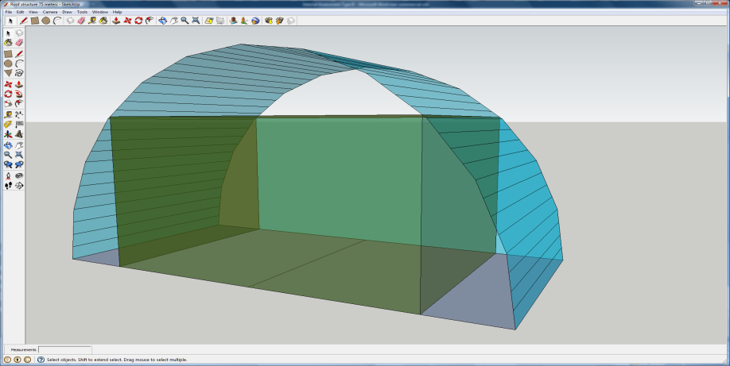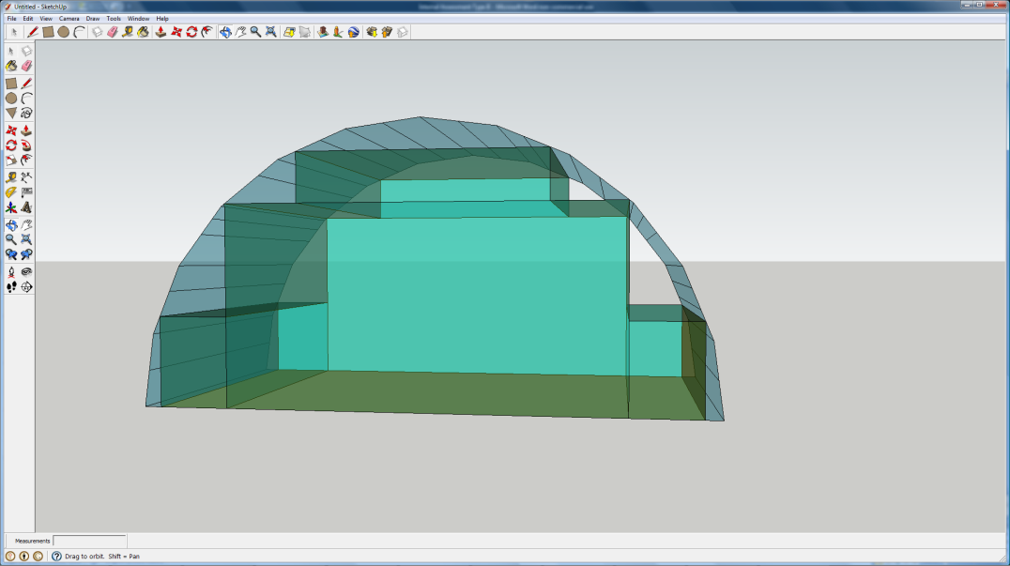 While a single cuboid of maximum volume inscribed inside an elliptical roof is fairly efficient occupying about 63.7% of the of total volume, there are significant portions of space that are wasted. The picture to the right shows the extent of the empty space available for use to the sides of the cuboid and on top of the cuboid. If multiple cuboids were used, more of this space could be utilized. However, filling this space haphazardly as I have shown in the second picture is not the most efficient use of space. The most efficient method of filling the space with multiple cuboids is to have one cuboid per level and stack each cuboid on top of the last. In this scenario, each cuboid will have a height of 3 meters and have the maximum width for that height. Each successive cuboid will have a smaller width than the last, but the sum of the volume and floor area of all of these levels should be much higher than before with only one cuboid. This is a process similar to the Riemann sum method except here there are a few more specifics in the process related to the scenario. A Riemann sum is a process of approximating the area under a curve by dividing the curve into sections, calculating the value of a point of in each of those sections, and using that point as the height and the length of the section as the width to calculate the area. Summing up these areas provides an approximation of the total area under the curve. Decreasing the size of the sections and increasing the number of sections allows for more accuracy in the approximation. This specific application of a Riemann sum requires that each section have an equal width of three meters as this is the height of a story. Also, the point at which the height is measured will always be the same place where the building meets the curve. To evaluate the Riemann sum in this situation, I am going to represent the facade as a two dimensional graph. I am going to rotate the facade by 90 degrees in the clockwise direction so that the current base of the facade will be the Y-axis. I will evaluate the half the area and then double it to account for the other half.

The cuboid occupies about 63.7% of the total volume, but that means there is over 35% of the space is wasted.

This haphazard arrangement of cuboids does occupy more volume, but there is a more efficient way.

With this switch of orientation, I need to develop the equation for the ellipse that defines the curve. This equation is the inverse of the curve defining the curve of the roof, but developing it is easy as well. The equation of an ellipse is shown below where a and b are half the major and minor axes:

$$\frac{x^{2}}{a^{2}}+\frac{y^{2}}{b^{2}}=1$$

Plugging in the values:

$$\frac{x^{2}}{{112.5}^{2}}+\frac{y^{2}}{{75}^{2}}=1$$

Rearranging:

$$y=\sqrt{{75}^{2}-\frac{{75}^{2}}{{112.5}^{2}}x^{2}}$$

Simplifying:

$$y=\sqrt{{75}^{2}-\frac{4}{9}x^{2}}$$

I will represent the sum of the area using sigma notation of the area summation formula:

$$\sum_{k=1}^{n}{f\left(a+k∆x\right)∆x}$$

$∆x$ will be replaced by three as that is the height of each story and thus the width of each section, $n$ will be 37 as that is the maximum number of stories in a building with a height of 112.5 meters. This also means that there will be 37 sections. *K* will start at one and *a* will be zero so that the height of each section is taken will be taken at the right hand side of the section at the point it intersects the curve. The function is the elliptical equation that I just developed.

$$\sum_{k=1}^{37}{(3)\sqrt{{75}^{2}-\frac{4}{9}{\left(3k\right)}^{2}}}$$

I could write this entire sum out, but I am going to use Microsoft Excel to quickly generate the values for each successive term and then sum it up.



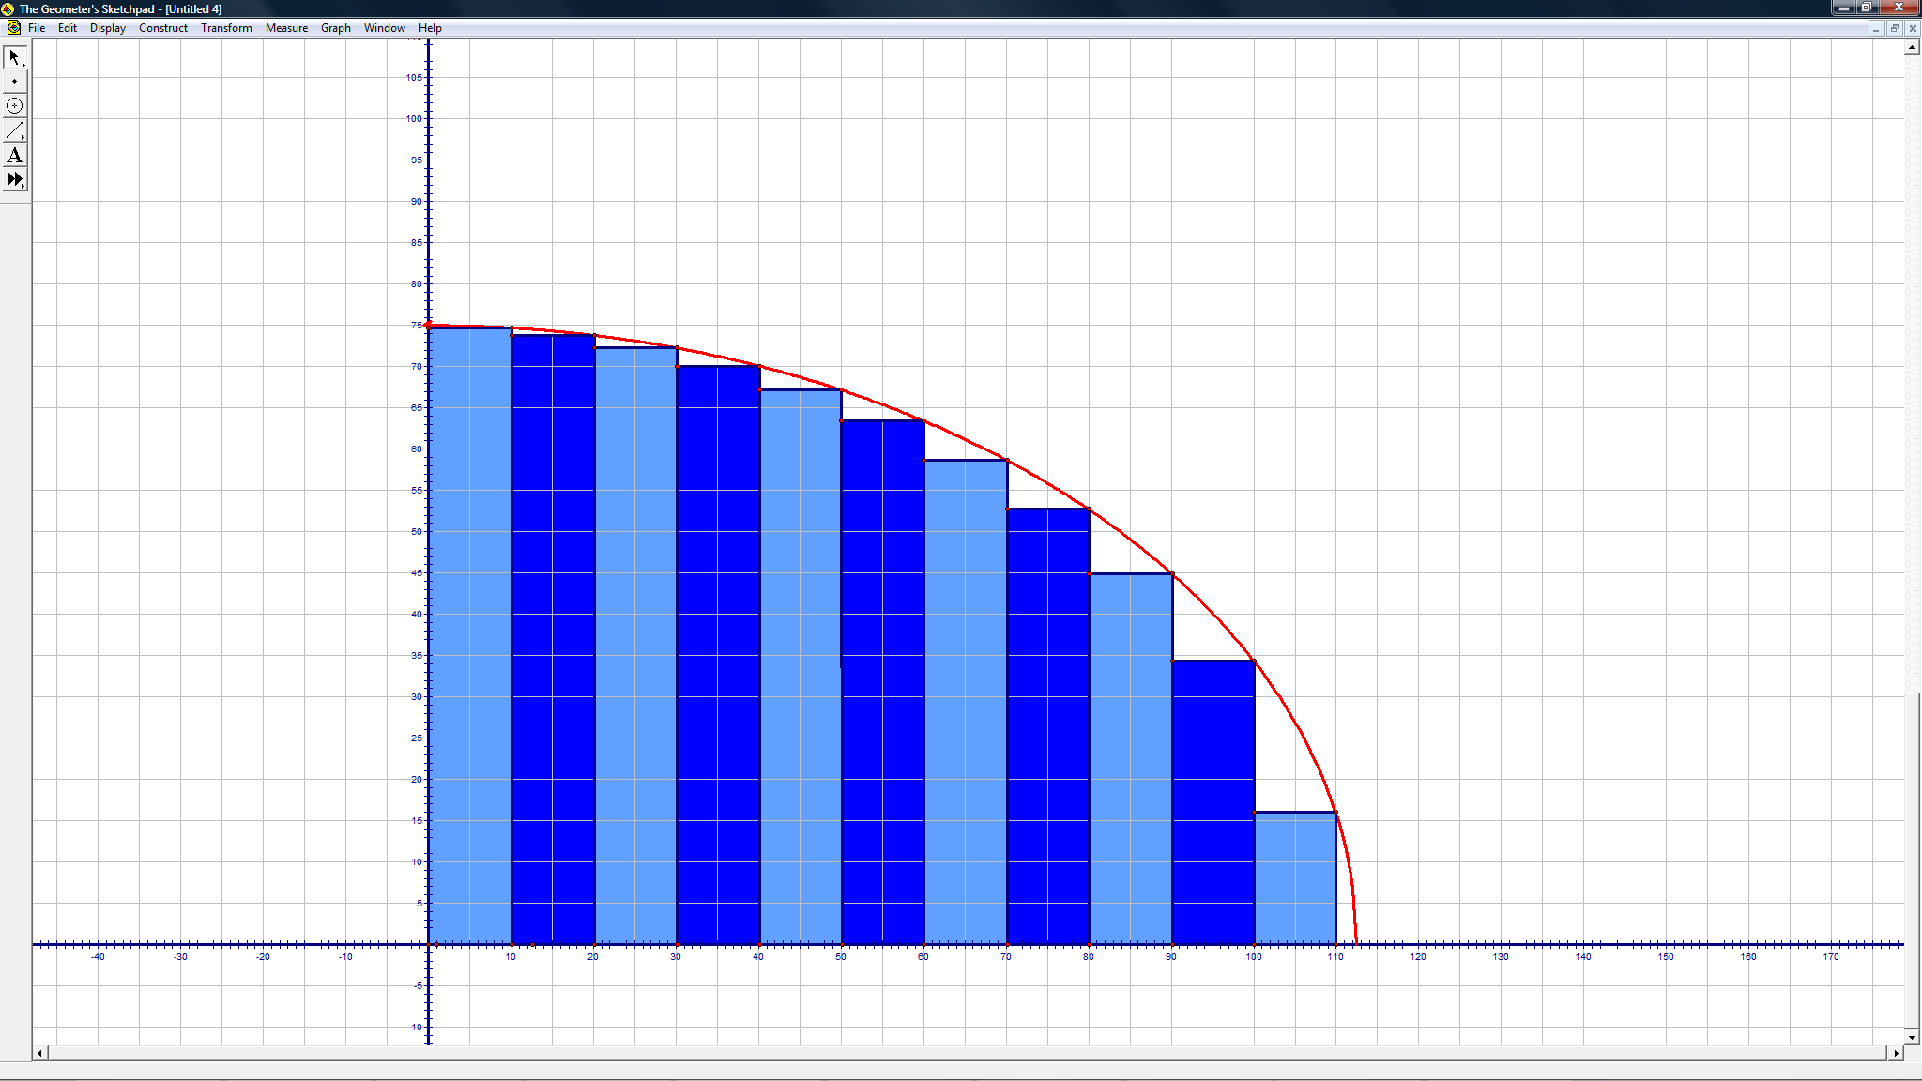 Each of the values in the table at the left represent a term of the series and is reported to three significant figures. Although this is relies on the same concept as a Riemann sum, it is not exactly one. The last 1.5 meters is completely disregarded as it is useless in forming a new level but this would not be done in a Riemann sum that approximated the area. However, in an attempt to maximize the floor area and volume, the volume of the under the roof should be fairly well approximated. For example, this sum took into account nearly all of the area of a fourth of the ellipse. The exact area of this section of the ellipse will be equal to $\frac{π\left(112.5\right)(75)}{4}$. The area that I found with my sum is about 6520 square meters. Dividing the area I found by the exact area results about 98.3%. This means that new design fills up about 98.3% of the total volume, a huge increase over the 63.7% that was filled up by a single cuboid. If the height of each story was decreased allowing for more stories, the percentage of the volume filled would increase. If the height of each story approached zero while the number of stories approached infinite, it would fill 100% of the volume and the area of the facade and the volume of the roof contained by the roof could be predicted.

This graph shows the process of dividing the area under the curve into sections. This graph has 11 sections of 10 meter width while I used 37 sections of 3 meter width in my calculation.

This increase in the ratio of used area to total area will result in a decrease of the ratio of wasted area to used area and equivalently, wasted volume to used volume. This ratio is approximately $\frac{π\left(112.5\right)(75)}{4}-6520:6520$ and means that only about 1.68% of the value of the volume of the office block is wasted volume. The lower this percentage, the better for efficiency and this is a huge improvement over the earlier percentage of 57.1%.

The next step is to evaluate the effect of using multiple cuboids on the office floor area. This is small variation of the previous process. Before, the width of the building at each story was multiplied by the height of the story to find the area of the facade that is occupied. This time, I want to multiply the width of the building by the length of the building to find the floor area.

The length of the building is 72 meters so the sum can be rewritten as:

$$\sum_{k=1}^{37}{(72)\sqrt{{75}^{2}-\frac{4}{9}{\left(3k\right)}^{2}}}$$

I am going to use Microsoft Excel to evaluate the sum again. Without presenting every term as I did last time, the sum is 313,000 square meters to three significant figures. Compared to the maximum floor area of only one cuboid at about 202,000 square meters, this is a significant advantage of about 111,000 square meters.

This summation method, based on the Riemann sum method for evaluating definite integrals, is a very efficient way (if one has the technology) to evaluate the floor area in and volume occupied by a series of office stories. The general models are:

$$Volume=2(l)\sum_{k=1}^{n}{f\left(kh\right)h}$$

$$Floor Area=2\left(l\right)\sum_{k=1}^{n}{f\left(kh\right)}$$

where the function is the inverse of the equation defining the curve in the first quadrant, *h* is the height of each story, *l* is the length of the building, and *n* is the number of stories that fit under the roof structure.

The only difference between the two equations is that the volume equation multiplies by the height of each story again which makes sense as multiplying the floor area by the height of the room would give the volume.

**Applying the Model:**

My model can be used to solve problems different than the one given:

I have been asked to find the maximum floor area and volume for a building that has multiple stories and each story can have a different height. The building is inscribed inside a roof with a facade of a quadratic curve with a height of 80 meters and a width of 100 meters. The length of the roof is 90 meters. The height of each story is 3.5 meters.

The model I have created can be applied to this situation very easily. The first step is to generate the equation defining the curve of the roof. The parabola must go through the points (-50,0), (0,80), and (50,0). The equation that achieves this is:

$$y=-\frac{80}{{50}^{2}}x^{2}+80$$

Solving for the inverse can be achieved by switching *x* and *y* and resolving for *y*.

$$x=-\frac{80}{{50}^{2}}y^{2}+80$$

$$\frac{{50}^{2}(80-x)}{80}=y^{2}$$

$$31.25(80-x)=y^{2}$$

$$y=\sqrt{31.25(80-x)}$$

With the equation of the inverse found, the second step is to determine how many stories can be built. As the height of each story is 3.5 meters and the total height is 80 meters, 22 stories can be built. Entering these values into the equation gives:

$$Floor Area=2\left(90\right)\sum_{k=1}^{22}{\sqrt{31.25\left(80-\left(3.5k\right)\right)}}$$

$$Volume=2\left(90\right)\sum_{k=1}^{22}{\left(\left(\sqrt{31.25\left(80-\left(3.5k\right)\right)}\right)\left(3.5\right)\right)}$$

Using Microsoft Excel to evaluate these sums results in a maximum floor area of about 132,000 square meters and a volume of about 466,000 cubic meters.

**Conclusion:**

After completing this investigation, I have created models and processes for determining the maximum floor area and volume for any one cuboid or series of cuboids under a curved roof structure. These models and processes are based on several conclusions made in this investigation:

1. Changing the dimensions of the curved structure does not affect the ratio of wasted space to used space when the volume of the cuboid inscribed in the roof is optimized.
2. The floor area is greatest when the product of the height, the width, and the length of the roof structure is greatest.
3. The optimized height of the building is a good guide for determining the number of stories that the building should have to maximize floor area.
4. Using multiple cuboids will increase both volume and floor area available with the maximum floor area and volume generated when arranging the cuboids in a manner similar to the Riemann sum method of evaluating a definite integral.

There are some considerations and limitations involved when using these models. When dealing with a single cuboid, it is possible that the loss of floor area related to constructing a new floor such as additional stairs, elevations, and restrooms could mean that the additional floor area gained by adding another floor is not actually usable. When dealing with multiple cuboids, the cost per square meter of floor area on the top story will be more expensive than on the first story because of the decrease in the ratio of floor area to the surface area of the walls needed to contain it. For example, the highest story could have one tenth the floor area of the first story but because the walls running the length of the building do not shrink in a similar manner, the cost of building the walls for this story is not one tenth the cost of building the first story. These financial considerations are not evaluated by this model but the cost of any building will always be a primary consideration and cannot be ignored. Also, because of the lack of information given regarding the height of each story, I made the assumption that every story will be a constant height and used three meters as that height in my investigation. However, it is unlikely that an actual building will have a constant height for every story; the ground floor is likely to have a much higher ceiling than the minimum two and half meters that the building code requires. The model also assumes that the thickness of the walls is zero and does not account for the loss of floor area due to the space taken up by the walls. Another consideration is that the model is based on the scenario that the cuboids are inscribed in the roof structure as if they could both occupy the same space. As this is not possible, the width of each building will have to be slightly less than the width this model predicts so that the building can fit inside the structure. Another factor affecting the width is that the roof structure will most likely not be perfectly elliptical, but rather an approximation of an ellipse using short straight sections. Depending on the length and angles of these sections, the width could be slightly wider or narrower than the model predicts.

Despite these limitations, I am satisfied with the model that I have created. My model can be adapted to buildings of various heights contained under any curve provided an equation modeling the curve can be created. While the limitations do prevent my model from exactly giving the floor area and volume of the building, they do not prevent it from giving an accurate estimate. Accounting for the width of walls or the variation in width because the roof structure is not a perfect ellipse could result in a loss in width of a meter or two which could possibly lower the amount of floor area by about one to three percent. It is not a truly significant amount at this stage of designing the building. To address these limitations, I would need to be provided with values regarding the actual design of the roof, the width of the walls, or the height of the lobby. As I was only given the dimensions of the base area, a possible range of values for the height, a minimum height of a room in a public building, and the instruction that the office block should be built inside a curved roof structure with a resemblance to a picture that looks like a parabola, I can only provide a rough estimate based on these specifications.

**My recommendation to the contractor on the design of the office and roof structure that is based on maximizing floor area and retaining the aesthetics of the curved roof structure is as follows:**

1. The curve of the facade should be elliptical with a height of 112.5 meters and a width of 150 meters. The equation of the ellipse when the building is centered on the x-axis with the base at $y=0$ is $y=\sqrt{{112.5}^{2}-\frac{9}{4}x^{2}}$. The length of the roof will be 72 meters.
2. There should be 37 cuboids stacked on one another all with a constant height of three meters and a constant length of 72 meters.
3. Each of these cuboids will have their center of width directly under the peak of the roof. The width will be greatest for the cuboid representing the first floor and smallest for the 37th cuboid. The width will vary according to the equation $y=\sqrt{{75}^{2}-\frac{4}{9}{(3n)}^{2}}$ where the width of the first story is given when *n* is one, the width of the second story is given when *n* is two and so on until the width of the 37th story is given when *n* is 37.
4. The floor area is about 313,000 square meters and the building occupies about 939,000 cubic meters, roughly 98.3% of the total volume of the space enclosed by the roof.

**Appendix A:**

The appendices contain the math for conclusions that I have presented in the main body of my paper but did not show the math for. I did not present all the math in the main body because it would have just been a repeat of a process I had just shown. However, the math is fairly important and instead of leaving it out altogether, I have presented it here. This math may seem redundant after reading the entire paper, but this math was instrumental in helping me reach my conclusions.

Appendix A contains the math behind Table 2: Optimized Area and ratio of possible space used for the four equations. In the main body, I showed the work for the quadratic equation, here I will show the work to find the optimized area and ratio of possible space used for the quartic, the sinusoidal, and elliptical equations.

**Equation for quartic curve:**

$$y=-\frac{1}{{36}^{3}}x^{4}+36$$

Area equation for the quartic curve: $$A=x\left(-\frac{1}{{36}^{3}}x^{4}+36\right)$$

$$A=\left(-\frac{1}{{36}^{3}}x^{5}+36x\right)$$

Derive:

$$A'=-\frac{5}{{36}^{3}}x^{4}+36$$

Set equal to zero and solve:

$$0=-\frac{5}{{36}^{3}}x^{4}+36$$

$$\frac{5}{{36}^{3}}x^{4}=36$$

$$x^{4}=\frac{{36}^{4}}{5}$$

$$x=\frac{36}{\sqrt[4]{5}}$$

Solve for height:

$$H=-\frac{1}{{36}^{3}}x^{4}+36$$

$$H=-\frac{1}{{36}^{3}}{\left(\frac{36}{\sqrt[4]{5}}\right)}^{4}+36$$

$$H=-\frac{36}{5}+36$$

$$H=28.8$$

Doubling $\frac{36}{\sqrt[4]{5}}$ gives the final width of $\frac{72}{\sqrt[4]{5}}$. Multiplying the width by the height gives the optimized area of a rectangle inscribed in this curve. The area is m2. The total area under the curve is expressed by the integral:

$$\int_{-36}^{36}{-\frac{1}{{36}^{3}}x^{4}+36 dx}$$

Using my TI-84 graphing calculator to evaluate the integral, the total area under the curve is 2073.6 square meters. The ratio of used space to total space is $\frac{2073.6}{\sqrt[4]{5}}:2073.6$ which simplifies to $\frac{1}{\sqrt[4]{5}}:1$.

**Equation for sinusoidal curve:**

$$y=36\cos{\frac{π}{72}x}$$

Area equation for the sinusoidal curve:

$$A=36x\cos{\frac{π}{72}x}$$

Derive using power rule:

$$A^{'}=36\cos{\frac{π}{72}x}+\left(\frac{π}{72}\right)\left(36x\right)\left(-\sin{\frac{π}{72}x}\right)$$

$$A^{'}=36\cos{\frac{π}{72}x}-\left(\frac{36x}{72}\right)\sin{\frac{π}{72}x}$$

Set equal to zero and solve:

$$0=36\cos{\frac{π}{72}x}-\left(\frac{36x}{72}\right)\sin{\frac{π}{72}x}$$

This cannot be solved algebraically so I approximated the solution graphically. I used WolframAlpha to find the solution in the domain of my equation (0,36). This value was approximately 19.7 meters. I used a more precise value (19.7174) as I solved for the height:

$$H≈36\cos{\frac{π}{72}(19.7174)}$$

$$H≈23.5$$

Doubling 19.7 gives a final width of approximately 38.4. Multiplying the width by the height gives an area of approximately 926 square meters. The total area under the curve is expressed by the integral:

$$\int_{-36}^{36}{36\cos{\frac{π}{72}x} dx}$$

Using my TI-84 graphing calculator to evaluate the integral, the total area under the curve is about 1650 square meters. The ratio of used space is about 926:1650 which is approximately 56.1%.

**Equation for elliptic curve:**

$$y=\sqrt{{36}^{2}-x^{2}}$$

Area equation for the elliptical curve:

$$A=x\sqrt{{36}^{2}-x^{2}}$$

Derive using power rule:

$$A^{'}=\sqrt{{36}^{2}-x^{2}}+\frac{x\left(-2x\right)\left(\frac{1}{2}\right)}{\sqrt{{36}^{2}-x^{2}}}$$

$$A^{'}=\sqrt{{36}^{2}-x^{2}}-\frac{x^{2}}{\sqrt{{36}^{2}-x^{2}}}$$

Set equal to zero and solve:

$$0=\sqrt{{36}^{2}-x^{2}}-\frac{x^{2}}{\sqrt{{36}^{2}-x^{2}}}$$

$$\frac{x^{2}}{\sqrt{{36}^{2}-x^{2}}}=\sqrt{{36}^{2}-x^{2}}$$

$$x^{2}={36}^{2}-x^{2}$$

$$2x^{2}={36}^{2}$$

$$x^{2}=\frac{{36}^{2}}{2}$$

$$x=\frac{36}{\sqrt{2}}$$

$$x=18\sqrt{2}$$

Solve for height:

$$H=\sqrt{{36}^{2}-x^{2}}$$

$$H=\sqrt{{36}^{2}-{(18\sqrt{2})}^{2}}$$

$$H=\sqrt{{36}^{2}-{2(18)}^{2}}$$

$$H=\sqrt{648}$$

$$H=18\sqrt{2}$$

Doubling $18\sqrt{2}$ gives the final width of $36\sqrt{2}$. Multiplying the width by the height gives an area of 1296 square meters. The total area under the curve is half the area of a circle with a radius of 36. Using the simple geometrical formula $A=πr^{2}$, the area is $648π$. The ratio of used area to total area is 1 $296:648π$ which simplifies to $\frac{2}{π}=1$.

**Appendix B:**

Appendix B contains the math involved with optimizing the volume of a cuboid inscribed in a roof structure of a quadratic curve with a width of 72 meters and a height of 54 meters.

**Equation of quadratic curve:**

$$y=-\frac{1}{24}x^{2}+54$$

Area equation for the sinusoidal curve:

$$A=-\frac{1}{24}x^{3}+54x$$

Derive:

$$A'=-\frac{3}{24}x^{2}+54$$

Set equal to zero and solve:

$$0=-\frac{3}{24}x^{2}+54$$

$$\frac{3}{24}x^{2}=54$$

$$x^{2}=\sqrt{432}$$

$$x=12\sqrt{3}$$

Solve for height:

$$H=-\frac{1}{24}x^{2}+54$$

$$H=-\frac{1}{24}{\left(12\sqrt{3}\right)}^{2}+54$$

$$H=-\frac{144(3)}{24}+54$$

$$H=36$$

Doubling $12\sqrt{3}$ gives the final width of $24\sqrt{3}$. Multiplying the width by the height gives the optimized area of $864\sqrt{3}$ square meters. The total area under the curve can be expressed by the integral:

$$\int_{-36}^{36}{=-\frac{1}{24}x^{2}+54 dx}$$

Using my TI-84 Calculator to evaluate the integral, the area is 2592 square meters. The ratio of wasted area to used area is 2592- $864\sqrt{3}:864\sqrt{3}$ which simplifies to $\sqrt{3}-1:1$.

The total volume contained by this cuboid is $129,600\sqrt{3}$ cubic meters. The ratio of wasted volume to used volume remains the same.

**Appendix C:**

Appendix C contains the math required to develop Table 5 which shows the effect of the height of the structure on optimized width, height, area of facade, and volume of the building and the total possible area of the facade.

|  |  |  |  |  |  |  |  |  |
| --- | --- | --- | --- | --- | --- | --- | --- | --- |
| Table 5: Patterns observed in the relationship between height and the optimal cuboid with the elliptical curve roof. | | | | | | | | |
| Height of Roof (m) | Optimized Width (m) | Optimized Height (m) | Optimized Area (m2) | Total Possible Area (m2) | Ratio of Wasted Space to Total Space | | Length (m) | Volume (m3) |
|  |  |  |  |  |  | () |  |  |

**Equation for elliptic curve:**

Area equation for the elliptical curve:

Derive using power rule:

Set equal to zero and solve:

$$0=\sqrt{h^{2}-\frac{h^{2}}{{36}^{2}}x^{2}}-\frac{\frac{h^{2}}{{36}^{2}}x^{2}}{\sqrt{h^{2}-\frac{h^{2}}{{36}^{2}}x^{2}}}$$

$$\frac{\frac{h^{2}}{{36}^{2}}x^{2}}{\sqrt{h^{2}-\frac{h^{2}}{{36}^{2}}x^{2}}}=\sqrt{h^{2}-\frac{h^{2}}{{36}^{2}}x^{2}}$$

$${\frac{h^{2}}{{36}^{2}}x}^{2}=h^{2}-\frac{h^{2}}{{36}^{2}}x^{2}$$

$${\frac{{2h}^{2}}{{36}^{2}}x}^{2}=h^{2}$$

$$x^{2}=\frac{{36}^{2}}{2}$$

$$x=\frac{36}{\sqrt{2}}$$

$$x=18\sqrt{2}$$

Solve for height:

$$H=\sqrt{h^{2}-\frac{h^{2}}{{36}^{2}}x^{2}}$$

$$H=\sqrt{h^{2}-\frac{h^{2}}{{36}^{2}}{\left(18\sqrt{2}\right)}^{2}}$$

$$H=\sqrt{h^{2}-\frac{{h^{2}(18}^{2})(2)}{{36}^{2}}}$$

$$H=\sqrt{h^{2}-\frac{h^{2}}{2}}$$

$$H=\sqrt{\frac{h^{2}}{2}}$$

$$H=\frac{h}{\sqrt{2}}$$

$$H=\frac{h\sqrt{2}}{2}$$

Doubling $18\sqrt{2}$ gives the final width of $36\sqrt{2}$. Multiplying the width by the height gives an area of $36h$ square meters. The area under the curve is equivalent to half the area of the ellipse that defines the roof. The area of an ellipse is equivalent to the product of π, half the major axis, and half the minor axis. Half the major axis is the height, half the minor axis is half the width. Therefore, the equation for the total area is:

$$A=\frac{36π\left(h\right)}{2}$$

$$A=18π\left(h\right)$$

The ratio of wasted space to used area is equal to the total area minus the used area to the used area: $18hπ-36h:36h$. As height is factor in both the used area and the total area, it divides out and the ratio is the constant $\frac{π}{2}-1:1$. As the area of the facade is $36h$ meters and the length is 150 meters, the volume is $5400h$ cubic meters.