IB Math HL 2 Series II Exit Slip 2 Paper 3 – Graphing Calculator Name

Part I:

1. The function  can be expanded as a power series in x, with its radius of convergence R, in the form

 .

a. State the value of R. [1 mark]

b. Determine the values of a and b for which the expansion of  agrees with

that of  up to and including the term . [4 marks]

c. Hence find a rational approximation to . [3 marks]

2. a. Find the first three terms of the Maclaurin series for . [6 marks]

b. Hence or otherwise, determine the value of  [4 marks]

Develop a power series for each of the following expressions. Include the first four non-zero terms in your answer.

3.  [Hint: substitute  and then develop the series for .]

4.  5.  6.  7. 

Part II:

1. Find the first 3 none zero terms of the Taylor series of the function  at .
2. a. Using the Maclaurin Series of , as far as , estimate ln 3.
3. Estimate the remainder.
4. Based on the answers of a and b. determine the best estimation of ln 3 in 4 decimal places.
5. Using the Maclaurin Series of , as far , as estimate  . Round your final answer to 4 decimal places.
6. a. Using the Maclaurin Series as far as , estimate .

b. Estimate the remainder.

1. Based on the answers of a and b , determine the best estimation of  in 4 decimal places.

IB Math HL 2 Series II Exit Slip 2 Paper 3 – Graphing Calculator Name

1. The function  can be expanded as a power series in x, with its radius of convergence R, in the form

 .

a. State the value of R. [1 mark]

b. Determine the values of a and b for which the expansion of  agrees with

that of  up to and including the term . [4 marks]

c. Hence find a rational approximation to . [3 marks]

2. a. Find the first three terms of the Maclaurin series for . [6 marks]

b. Hence or otherwise, determine the value of  [4 marks]

Develop a power series for each of the following expressions. Include the first four non-zero terms in your answer.

3.  [Hint: substitute  and then develop the series for .]

4.  5.  6.  7. 

Markscheme

1. (a)  A1

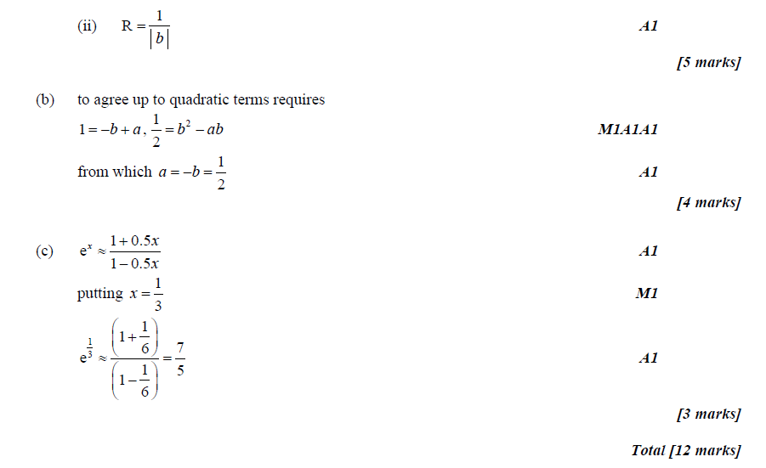

2.

