The Logistic Equation

The exponential growth model was derived from the fact that the rate of change of a variable y is proportional to the value of y. You observed that the differential equation has the general solution. The exponential growth is unlimited, but when describing a population, there often exits some upper limit L past which growth cannot occur. The upper limit L is called the carrying capacity, which is the maximum population y(t) that can be sustained or supported as time t increases. A model that is often used to describe this type of growth is the logistic differential equation (“Calculus by Larson”)



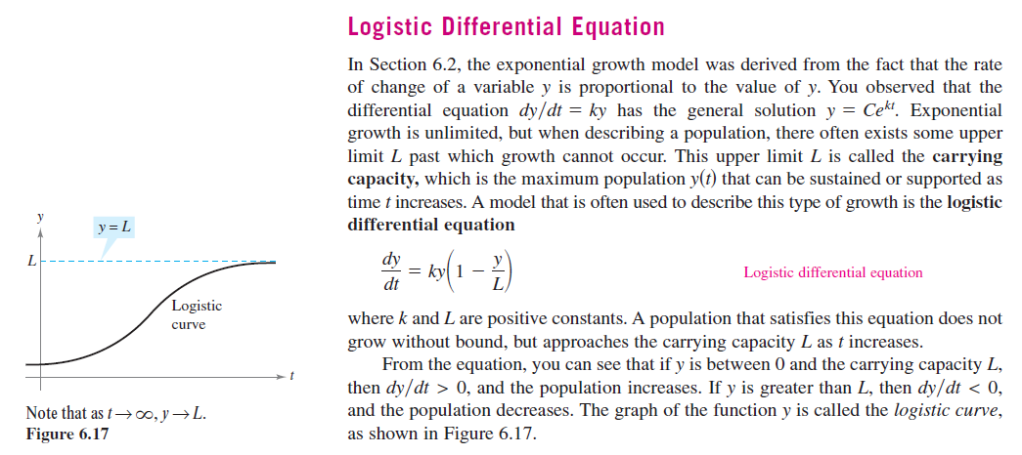Let’s Solve the differential equation .

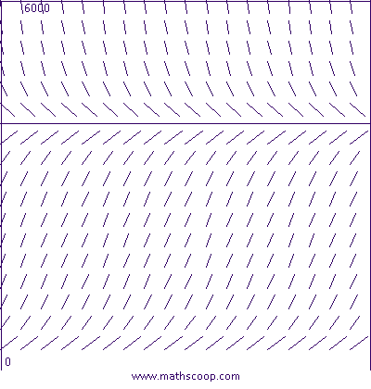Example Practice) A state game commission releases 40 elk into a game refuge. After 5 years, the elk population is 104. The commission believes that the environment can support no more than 4000 elk. The growth rate of the elk population p is , , where to is the number of years.

a. Solve the differential Equation to model for the elk population in terms of t.

b. Use the points (0, 40) and (5, 104) to verify that this is a

reasonable slope field for the differential equation.

c. Use the model to estimate the elk population after 15 years.

d. Find the limit of the model as .