Pre HL : Unit 2 IB Exam Style Questions: Similar Questions will show in Unit 2 Exam

|  |  |
| --- | --- |
| 1. |  |
| 2. | 3. Given  and  a) Calculate  b) |
|  | 4. Find all values of x that satisfy the inequality, . |
| 5. |  |
| 6. | Using your graphing calculator: |

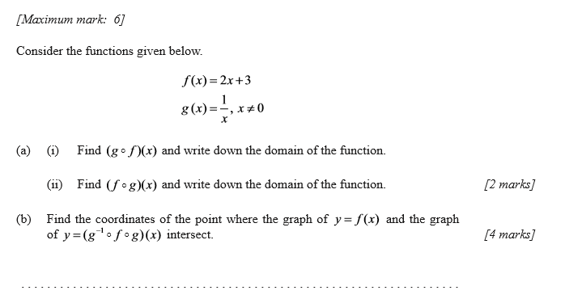

|  |  |
| --- | --- |
|  |  |

7. a) or b) keep just one

|  |  |
| --- | --- |
|  |  |

8.