IB Pre HL Sinusoidal Modeling (Day 2)

The height of the tide above mean sea level on January 24th at Cape Town is modelled approximately by  meters where *t* is the number of hours after midnight.

a. Graph  for .

b. When is high tide and what is the maximum height?

c. What is the height of the tide at 7 am?

d. A ship can cross the harbor provided the tide is at least 2 meters above mean sea level. For what values of *t* is crossing possible on January 24th?

Rehearsal:

The average depth of the water at a particular point on the beach varies sinusoidally with time due to the motion of the tides. The figure shows the depth, y, measured in feet, at such a point as a function of x, measured in hours after midnight at the beginning of January 1. The particular equation of the sinusoid is



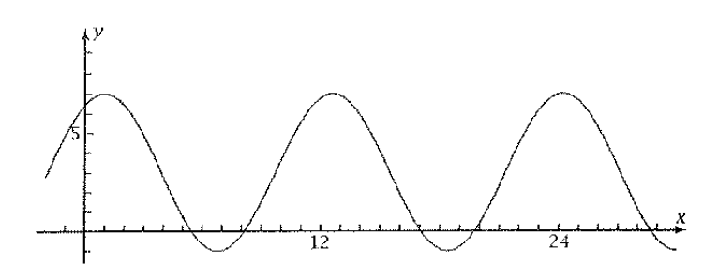

1. What is the deepest the water gets? What is the first time on January 1 at which the water is this deep? What is the period of this function?
2. Where the graph dips below the x-axis, the water is completely gone, leaving the pint on the beach out of the water. At what time does the lowest tide first occur on January 1? How deep a hole would you have to dig in the sand so that water would flow into it at that time?
3. Calculate the depth of the water at 4:00 pm on January 1. Who that the answer agrees with the graph?
4. Find the graphically the first interval of times on January 1 for which the water is completely gone.