IB Pre HL Inverse Trigonometric Functions Name

Warm Up

1. Sketch a complete graph of 
2. Sketch a complete graph of 

What is inverse trigonometric?

If  is given,  is found by . In order not to be confused by the inverse trig  and the reciprocal trig , is also expressed

.

Since , , and  are all many to one functions , their domains must be restricted in order for them to have inverse functions.

|  |  |  |  |
| --- | --- | --- | --- |
| Functions | Invers functions | Definition and domain | Range |
|  | () |  |  |
|  | () |  |  |
|  | () |  |  |

The graphs of these inverse functions.

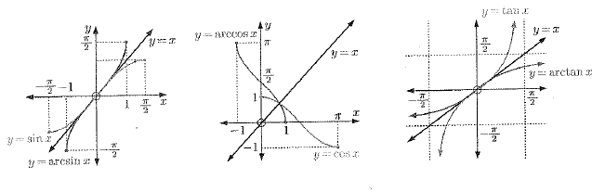

Example 1) Find the exact value of .

Example 2) Find the exact value of 

Practice)



