**Properties of Definite Integrals**

|  |  |  |
| --- | --- | --- |
| General Property: | Warm up: | |
| Subdivision Rule: If any number C such that ,  Then | Example 1) | |
| Dominant Rule: If f and g are integrable on the closed interval [a, b] and , | Example 2)  Given and ,evaluate | |
|  |  | |
| Example 3) Given , Evaluate | |  |
|  | |  |

**Application WS #2 Name:______**

1.

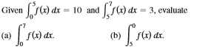

2. Evaluate each definite integral using geometric formulas.

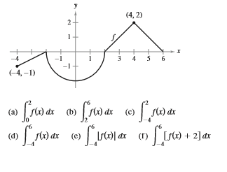

3. Evaluate the definite integral of .

4. Evaluate the definite integral of 