IB Pre HL 6E: Sum and Product of Roots Theorem Name: ____________________

Exploration:

1) Given,

a) Write the equation in the form of .

Answer: ___________________

b) What does S equal to? __________________? What does P equal to? ________________________

2) Given,

a) Write the equation in the form of.

Answer: ___________________

b) What does S equal to? __________________? What does P equal to? ________________________

3) Given,

a) Write the equation in the form of.

Answer: ___________________

b) What does S equal to? __________________? What does P equal to? ________________________

4) Given,

a) Write the equation in the form of.

Answer: ___________________

b) What does S equal to? __________________? What does P equal to ? ________________________

5) Observing the patterns of above exercise, what do S and P to, for the 5the degrees of polynomial of  if it is factored to be 

S= ____________________________________ P= ________________________

For the polynomial equation, 

(which can also be written as ) and where 

* The sum of the roots is ( ).
* The product of the roots is ( ) if n is odd.
* The product of the roots is ( )if n is even.
* For the polynomial equation, 
*  where  are the roots of the polynomial

Example 1) Find the sum and product of the roots of 

Example 2) A real polynomial has the form . The graph of  has y-intercept 180. It cuts the x-axis at 2 and 6, and does not meet the x-axis anywhere else. Suppose the other two zeros are , . Use the sum and product formulae to find m and n.

Example 3)

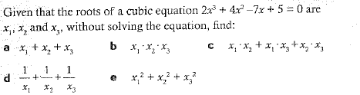

More Practice) Work in your notes

1.

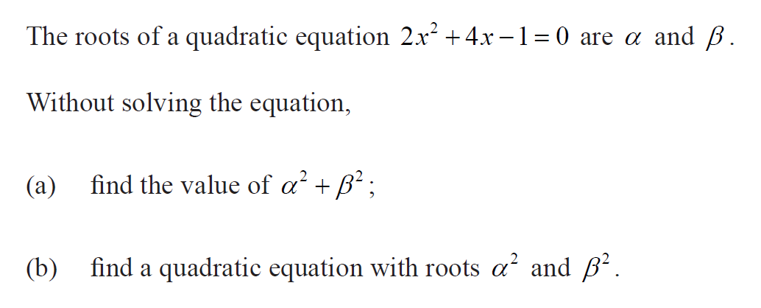

2.

