**IB Pre HL Chapter 5 IB questions Name: _________________**

1. Hint: the period of a sinusoidal function is 

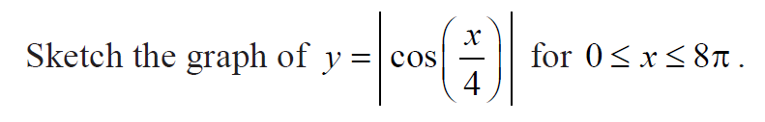

2. Sketch g(x).

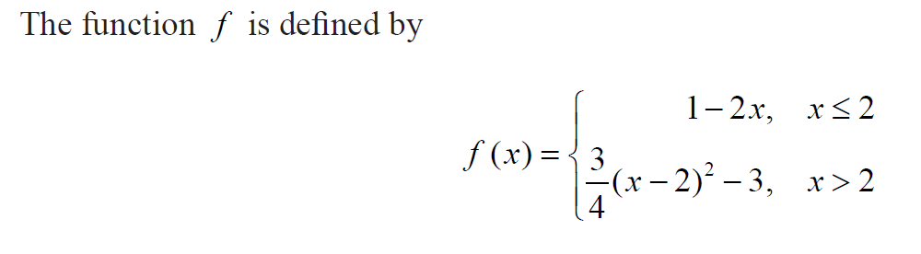

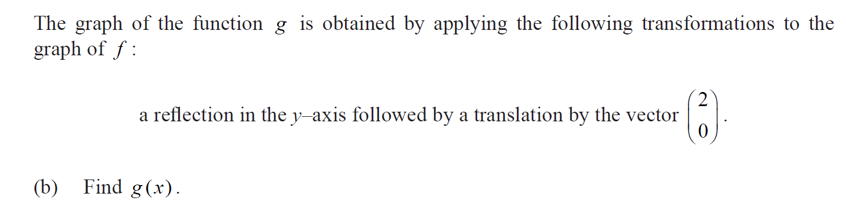

3.

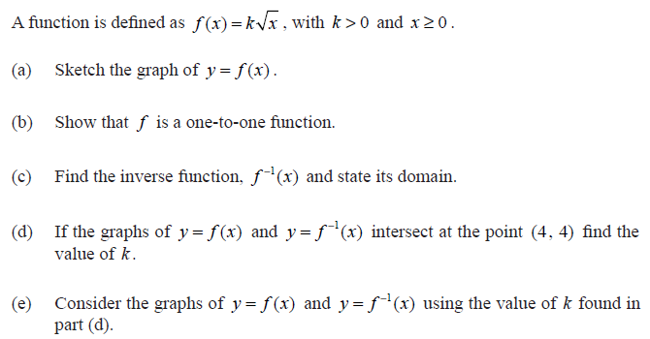

4. Practice this again.

