**Pre HL Exit Slip : Show your work Name: ____________________**

1. Expand  and find the constant term.

2. Find the value of k when the coefficient of  1125 in the expansion of.

3.

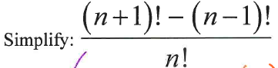

4. What is the coefficient of  in ?

5. 48 people are about to get on a double-decker bus which seats 24 people on each level. However, 8 people refuse to travel upstairs, and 6 people refuse to travel downstairs. How many ways are there of choosing which passengers travel upstairs and which passengers travel downstairs?

6. 10 people came to a book club to discuss "You are joking, Mr. Feynman". The seats are arranged in a circle facing toward center.

a. How many different ways can the seats be arranged ?

b. How many different ways can the seats be arranged when the couple, John and Jill, in the group are allowed to sit together?