IB PreHL Rational Function IB Questions Name: __________________________
Period:________
1 | 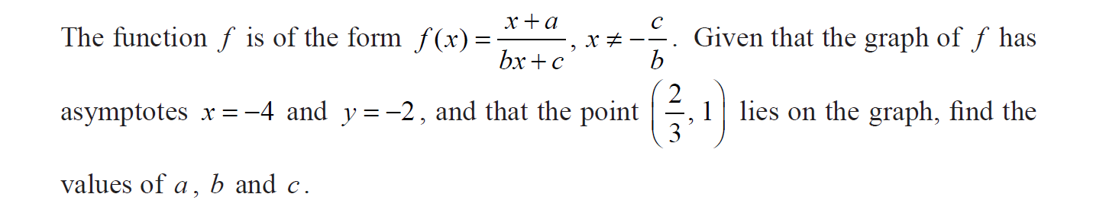
2 | 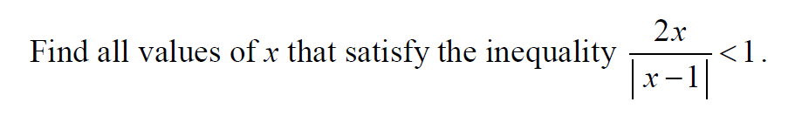
3 | 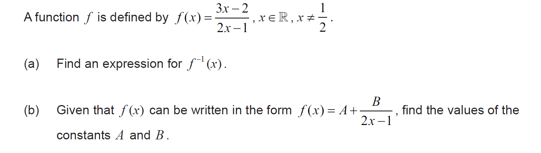
4  Use Cal |  | 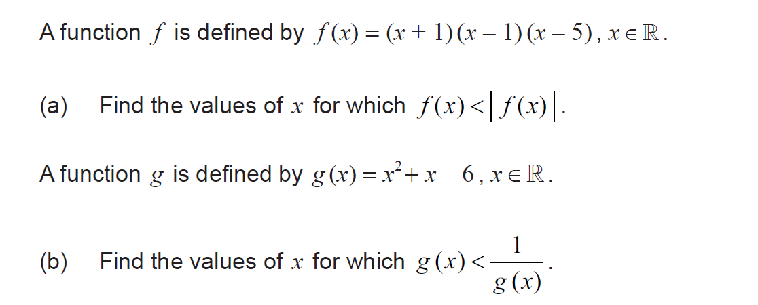
5 | 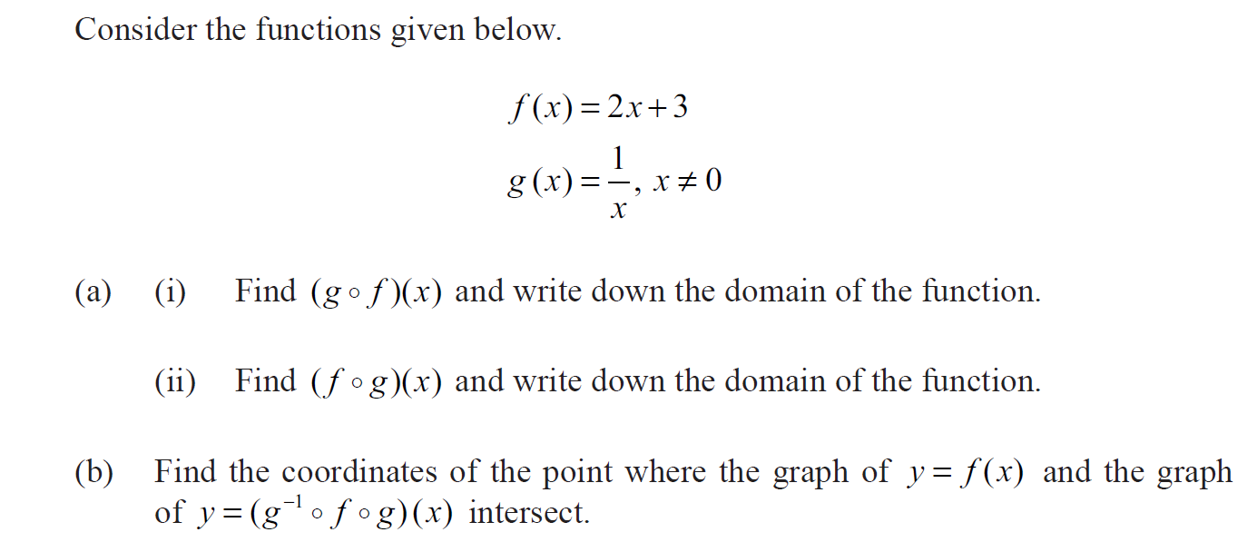
6 | 