**IB Math HL1 Area and Volume IB Questions** Name: ____________________

Calculator is okay.

|  |  |
| --- | --- |
| 1 |  |
| 2 |  |
| 3 |  |
| 4 |  |
| 5 |  |
|  |  |
| 6 |  |
|  |  |

|  |  |
| --- | --- |
| 7  8  9 |  |

|  |  |
| --- | --- |
| 10 |  |

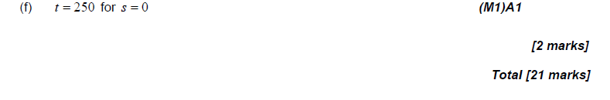

1. A particle is moving along a line so that is velocity is  feet per second at time t.

1. Determine the speed is increasing and decreasing when t = 3. Show your reasoning.