IB Pre HL Ch 6 (Complex numbers) IB questions Name: ____________________________



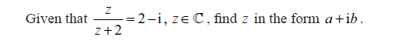

1. Given z is the complex number, , and . Find 
2. Find  when 



5

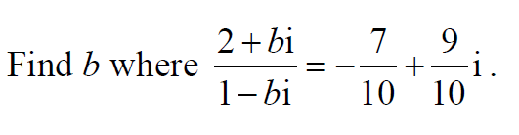

6.

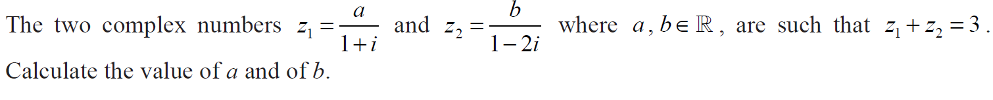

7

 is a root of . Find all possible values of a and b.

IB Pre HL Name: _____________________________

Chapter 6 Exit Slip Period: _____

**No Calculators!!**

**Simplify**

**1.  2. **

3. Simplify  and writewhere

4. Solve for  and : 

5. Write the equation, , that have a root of.