6.1 and 6.2 Practice

1. Consider the differential equation .

|  |  |  |  |  |
| --- | --- | --- | --- | --- |
| a. Sketch a slope field for the differential  equation at the 5 points indicated. |  | b. Use your slope field to explain why a solution could not have this graph. |  | c. Find the particular solution given the initial condition  if . |
|  |  |  |  |  |

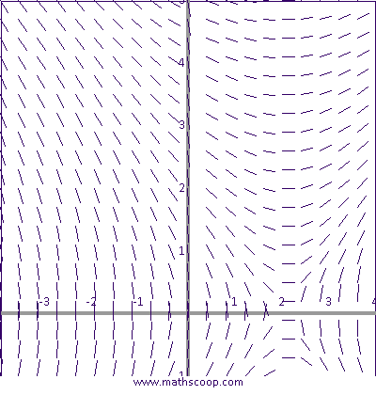

2. For the slope field at right, sketch the graph of

the solution that satisfies the given initial condition.

a. (-2, 4) b. (-2, 1)

3. Given  and initial condition (-2, 7),

use Euler’s method with an increment of h = 0.1 to

approximate the value of y when x = -2.4.

4. Given  , find a general solution.

5. Given , find the particular solution if the curve contains (-2, -9) and express y in terms of x.

6.1 and 6.2 Practice

1. Consider the differential equation .

|  |  |  |  |  |
| --- | --- | --- | --- | --- |
| a. Sketch a slope field for the differential  equation at the 5 points indicated. |  | b. Use your slope field to explain why a solution could not have this graph. |  | c. Find the particular solution given the initial condition  if . |
|  |  |  |  |  |



2. For the slope field at right, sketch the graph of

the solution that satisfies the given initial condition.

a. (-2, 4) b. (-2, 1)

3. Given  and initial condition (-2, 7),

use Euler’s method with an increment of h = 0.1 to

approximate the value of y when x = -2.4.

4. Given  , find a general solution.

5. Given , find the particular solution if the curve contains (-2, -9) and express y in terms of x.

Solve the differential equations.

6.  7.  8.  9. 

10. Find the particular solution to the differential equation  if *M* = 3 when *t* = 2. Solve for *M.*

11. Newton’s Law of Cooling says that the rate at which an object’s temperature is changing is proportional to the difference between its temperature and the temperature of the surrounding medium. A piece of metal at room temperature () is placed in an oven at . After 12 minutes, the temperature of the metal is .

a. Write a differential equation that relates the temperature of the metal, *T*, to time, *t*, in minutes. Solve the differential equation for T using the given information.

b. Use your equation to determine the temperature of the metal after one hour.

12. Bacteria in a lab culture grow in such a way that the rate of change of bacteria is directly proportional to the number of bacteria present. After 45 minutes, the amount of bacteria has increased by 15%.

a. After how many minutes will the amount of bacteria double?

b. By what percent will the bacteria have increased after 5 hours?

13. A chemical reaction uses up substance Q at a rate proportional to the square root of the amount of Q present. If after 5 minutes, there are 12 grams of Q present and after 8 minutes there are 3 grams present, how much of Q was present at the start of the reaction?

Solve the differential equations.

6.  7.  8.  9. 

10. Find the particular solution to the differential equation  if *M* = 3 when *t* = 2. Solve for *M.*

11. Newton’s Law of Cooling says that the rate at which an object’s temperature is changing is proportional to the difference between its temperature and the temperature of the surrounding medium. A piece of metal at room temperature () is placed in an oven at . After 12 minutes, the temperature of the metal is .

a. Write a differential equation that relates the temperature of the metal, *T*, to time, *t*, in minutes. Solve the differential equation for T using the given information.

b. Use your equation to determine the temperature of the metal after one hour.

12. Bacteria in a lab culture grow in such a way that the rate of change of bacteria is directly proportional to the number of bacteria present. After 45 minutes, the amount of bacteria has increased by 15%.

a. After how many minutes will the amount of bacteria double?

b. By what percent will the bacteria have increased after 5 hours?

13. A chemical reaction uses up substance Q at a rate proportional to the square root of the amount of Q present. If after 5 minutes, there are 12 grams of Q present and after 8 minutes there are 3 grams present, how much of Q was present at the start of the reaction?