|  |  |
| --- | --- |
| IB Math HL1  Euler’s Method  “OY-ler” | Name: _____________________ Period: ___________   * **Numerical** analysis of a differential equation * Use  to determine the slope of the solution at a starting point . * Use  to find each subsequent point. |
|  |  |

Euler’s method is to find an approximation to a particular solution by a numerical analysis, , for a given differential equation.

Example) Given  and 

a. Use Euler’s method with step size of 0.5 to find an approximation value for . Give your answer in 4 decimal places.

|  |  |  |  |  |  |  |  |  |  |  |  |
| --- | --- | --- | --- | --- | --- | --- | --- | --- | --- | --- | --- |
| *n* | 0 | 1 | 2 | 3 | 4 | 5 | 6 | 7 | 8 | 9 | 10 |
|  |  |  |  |  |  |  |  |  |  |  |  |
|  |  |  |  |  |  |  |  |  |  |  |  |

b. In the figure show the slope filed for this differential equation. Plot the y-values from (a) on the slope field. Connect the points with line segments.

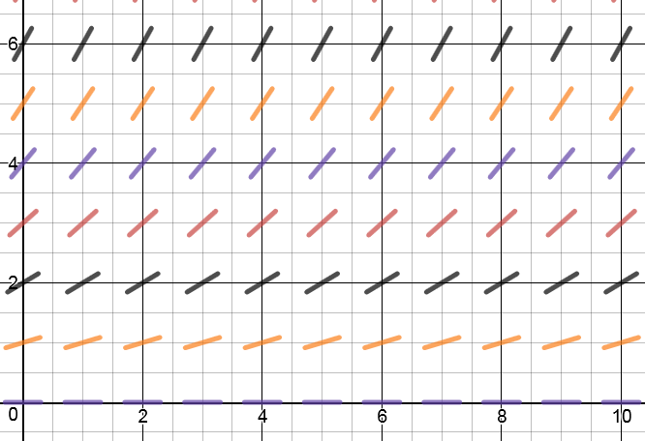

c. Solve the differential equation algebraically. Find the particular solution. If , how well does the value of y by Euler’s method agree with the actual value? Discuss the result why this approximation is greater or smaller than the true value of y.

1. Use Euler’s Method to approximate the particular solution of the differential equation  passing through the point  on the domain. Use a step of 

|  |  |  |  |  |  |  |  |  |  |  |  |
| --- | --- | --- | --- | --- | --- | --- | --- | --- | --- | --- | --- |
| *n* | 0 | 1 | 2 | 3 | 4 | 5 | 6 | 7 | 8 | 9 | 10 |
|  |  |  |  |  |  |  |  |  |  |  |  |
|  |  |  |  |  |  |  |  |  |  |  |  |

2. For the differential equation in #1, verify that the exact solution is . Compare this exact solution with the approximate solution obtained in #1 by plotting.



**Practice with IB Questions:**

1. Consider the differential equation, where  and . Use Euler’s method with  to find an approximate value when  Give the final answer to 3 significant figures.

2. Consider the differential equation and . Use Euler’s method with  to find an approximate value when  Give the final answer to 3 significant figures.