Investigating Pollution and Its Lasting Effects

Introduction:
A problem that we are constantly reminded of in this day and age is the effect that we are having on our planet. In biology classes, environmental brochures, or even television ads, we are always told how our world is headed towards some sort of irreversible wasteland, and that the someday when it will be too late is coming quicker than ever. As a teenager this has scared me. I don’t want the world I know and love to get progressively worse. I want it to stay the same or improve, not only for the latter part of my own life, but for the lives of my prosperity. I enjoy doing many things outdoors and could not imagine what life would be like if we took away our own privilege to spend time in the outdoors through the constant abuse of Mother Nature.
I thought at first it was far-fetched, but I wanted to see if there was a way that math would be able to apply and help us to understand the state of our planet. I obviously won’t be able to do a mathematical analysis of the entire planet’s biosphere, but instead I decided to analyze one ecosystem for one type of pollutant. This is the first limitation of my procedure. I will not be able in any way truly predict when we can eradicate pollution, or truly be able to do any large scale versions of this with my math knowledge. But, my purpose in this experiment is to explore the possibility of doing a similar experiment on a larger scale by first investigating it on a small one.
I grew up in the state of Utah which is known for its beautiful desert scenery; but also for its lack of water. One of the larger lakes in Utah, is coincidentally named Utah Lake and is located almost exactly in the geographic center of the state. Utah Lake was in the news quite a bit while I lived in Utah for being one of the dirtiest lakes in the United States—it was absolutely disgusting and no one could swim in it or take part in any other recreational activities because of the pollution.
Upon researching more about the data and numbers behind Utah Lake being one of the dirtiest lakes in the country, I came across some information that pointed me to where I should begin my exploration. One of the major problems in the Utah Lake, besides garbage and sewage, and which may have been a result of the previously mentioned, was the high level of ammonia in the water.² Ammonia is a chemical that can be dangerous and unhealthy if it gets into a person’s system through drinking or ingesting during recreation. Ammonia can cause irregular growth for youth in large quantities and can cause for digestive tract abnormalities in people of all ages.³ National standards say that a lake is high if it is above $5$ milligrams per deciliter and dangerously high if it is above $10$ milligrams per deciliter; ³ at its worst, Utah Lake registered at over $50$ milligrams of ammonia per deciliter. ²

Collected Data:
Below is the data that I was able to attain from the Utah department of ecology for the ammonia levels in Utah Lake.

Ammonia Levels Over Time²
Date of Sample | Ammonia (mg/dL)
Feb-$93$ | $$0.345$$
Apr-$93$ | $$0.426$$
Jun-$93$ | $$0.446$$
Aug-$93$ | $$0.467$$
Oct-$93$ | $$0.477$$
Dec-$93$ | $$0.528$$
Feb-$94$ | $$0.675$$
Apr-$94$ | $$0.772$$
Jun-$94$ | $$0.782$$
Aug-$94$ | $$0.847$$
Oct-$94$ | $$0.880$$
Dec-$94$ | $$0.912$$
Feb-$95$ | $$0.989$$
Apr-$95$ | $$1.000$$
Jun-$95$ | $$1.122$$
Aug-$95$ | $$1.155$$
Oct-$95$ | $$1.177$$
Dec-$95$ | $$1.233$$
Feb-$96$ | $$1.312$$
Apr-$96$ | $$1.323$$
Jun-$96$ | $$1.414$$
Aug-$96$ | $$1.414$$
Oct-$96$ | $$1.448$$
Dec-$96$ | $$1.793$$
Feb-$97$ | $$1.827$$
Apr-$97$ | $$2.003$$
Jun-$97$ | $$2.167$$
Aug-$97$ | $$2.548$$
Oct-$97$ | $$2.572$$
Dec-$97$ | $$3.043$$
Feb-$98$ | $$3.067$$
Apr-$98$ | $$3.189$$
Jun-$98$ | $$3.238$$
Aug-$98$ | $$3.299$$
Oct-$98$ | $$3.373$$
Dec-$98$ | $$3.385$$
Feb-$99$ | $$3.508$$
Apr-$99$ | $$3.905$$
Jun-$99$ | $$4.054$$
Aug-$99$ | $$4.205$$
Oct-$99$ | $$4.280$$
Dec-$99$ | $$4.292$$
Feb-$00$ | $$4.305$$
Apr-$00$ | $$4.330$$
Jun-$00$ | $$4.355$$
Aug-$00$ | $$4.393$$
Oct-$00$ | $$4.683$$
Dec-$00$ | $$4.797$$
Feb-$01$ | $$5.166$$
Apr-$01$ | $$5.179$$
Jun-$01$ | $$5.422$$
Aug-$01$ | $$5.615$$
Oct-$01$ | $$5.705$$
Dec-$01$ | $$5.744$$
Feb-$02$ | $$5.757$$
Apr-$02$ | $$5.847$$
Jun-$02$ | $$5.886$$
Aug-$02$ | $$5.925$$
Oct-$02$ | $$6.915$$
Dec-$02$ | $$6.941$$
Feb-$03$ | $$7.639$$
Apr-$03$ | $$7.931$$
Jun-$03$ | $$8.771$$
Aug-$03$ | $$9.040$$
Oct-$03$ | $$9.309$$
Dec-$03$ | $$9.336$$
Feb-$04$ | $$9.646$$
Apr-$04$ | $$9.660$$
Jun-$04$ | $$10.012$$
Aug-$04$ | $$10.311$$
Oct-$04$ | $$10.542$$
Dec-$04$ | $$10.556$$
Feb-$05$ | $$12.119$$
Apr-$05$ | $$12.202$$
Jun-$05$ | $$12.409$$
Aug-$05$ | $$12.409$$
Oct-$05$ | $$12.479$$
Dec-$05$ | $$12.659$$
Feb-$06$ | $$12.866$$
Apr-$06$ | $$13.311$$
Jun-$06$ | $$14.121$$
Aug-$06$ | $$15.343$$
Oct-$06$ | $$15.950$$
Dec-$06$ | $$16.517$$
Feb-$07$ | $$16.659$$
Apr-$07$ | $$16.744$$
Jun-$07$ | $$17.942$$
Aug-$07$ | $$18.071$$
Oct-$07$ | $$18.371$$
Dec-$07$ | $$19.089$$
Feb-$08$ | $$20.822$$
Apr-$08$ | $$22.422$$
Jun-$08$ | $$23.153$$
Aug-$08$ | $$23.886$$
Oct-$08$ | $$24.474$$
Dec-$08$ | $$24.768$$
Feb-$09$ | $$26.096$$
Apr-$09$ | $$33.281$$
Jun-$09$ | $$37.235$$
Aug-$09$ | $$41.378$$
Oct-$09$ | $$49.887$$
Dec-$09$ | $$52.618$$
Feb-$10$ | $$51.830$$
Apr-$10$ | $$47.642$$
Jun-$10$ | $$47.564$$
Aug-$10$ | $$46.889$$
Oct-$10$ | $$43.356$$
Dec-$10$ | $$38.153$$

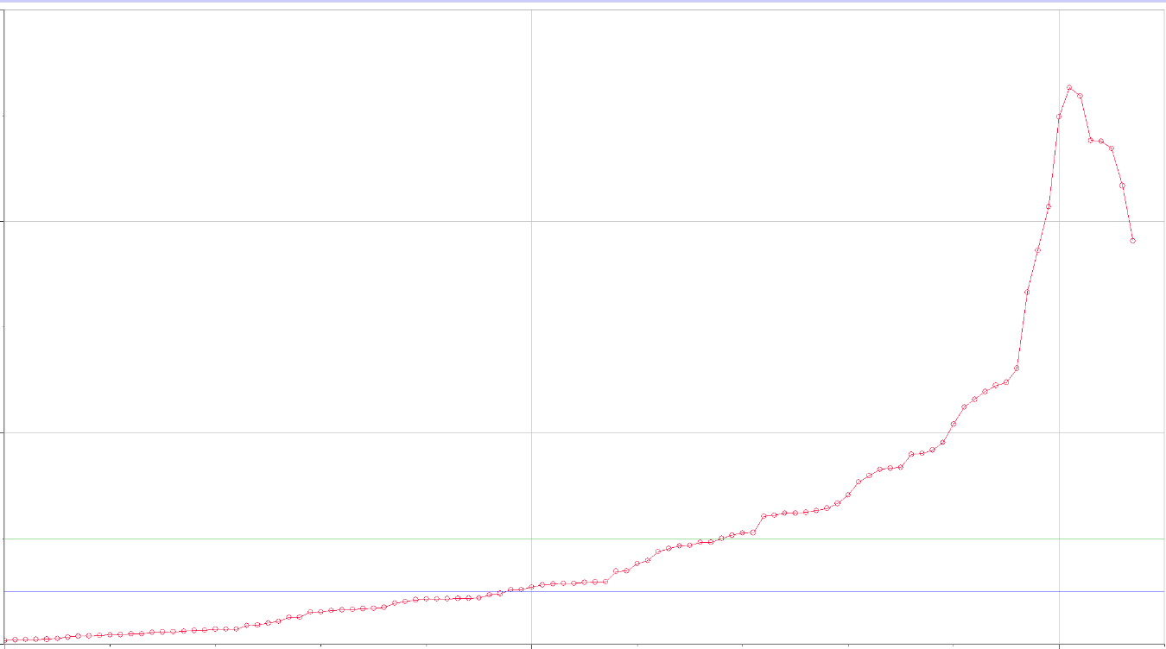
The data above was collected over a $17$ year period. The state only started doing an in-depth analyses on the data in the year $2000$ though when the levels climbed upward of $4$ milligrams per deciliter. As can also be seen by the drop in the last few registered levels that starting in $2010$ Utah Lake actually began to become cleaner. This is because during $2009$ the state of Utah passed very strict laws that prohibited pollution in any lake.¹ The data above can also be represented graphically as is seen below.
40
Ammonia Level (mg/dL)
20
Ammonia Levels in Utah Lake (1993-2007)
Months after February 1993
50
100

The green line on the graph represents the dangerous limit that was set aside by the government. The blue line is the recommended governmental limit of five milligrams per deciliter. These lines are put on to extenuate how out of hand the situation became in the Utah Lake over time.
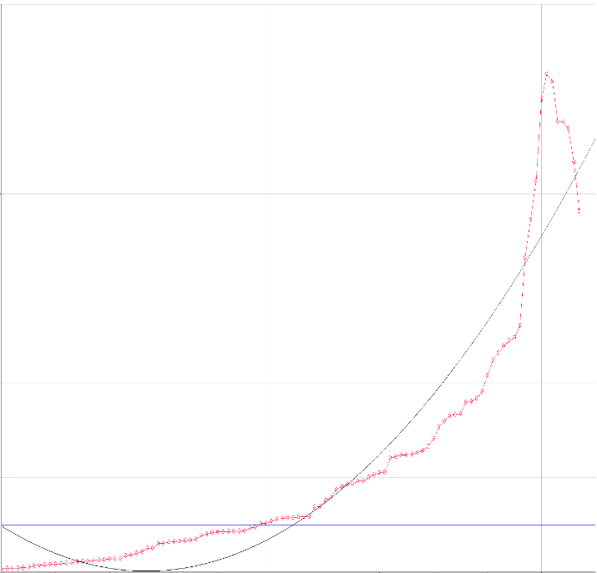
Originally I thought there was going to be the simple answer of just finding a line of regression for the equation and that would be what I would be able to use in order to compute when the lake will reach a clean level again. But, as I started to run through the experiment, and run regression equations, I discovered that not one of the graphs made sense because they did not take into account that the pollution had been going down of late, and would have given me some very unrealistic numbers. Below I have shown two graphs; one is a graph that I thought could have made sense logically of a cubic regression, and just to prove my point the other is one that wouldn’t make as much sense logically and is a sine regression.
Ammonia Level (mg/dL)
Cubic Regression of Ammonia Levels in Utah Lake (1993-2007)
Sinusoidal Regression of Ammonia Levels in Utah Lake (1993-2007)
40
20
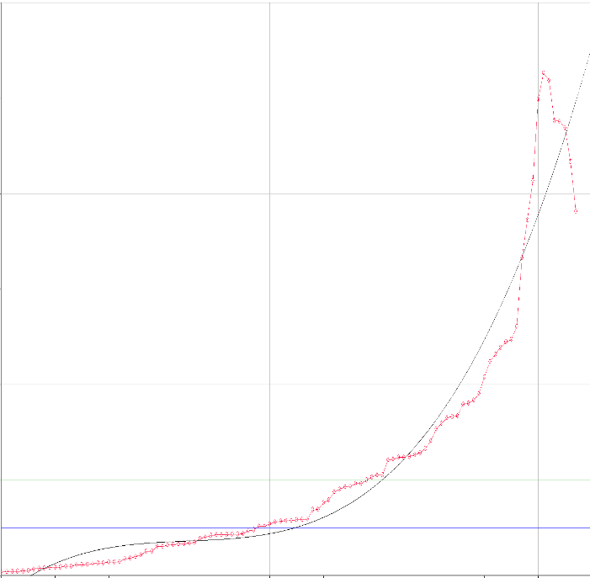
100
100
50
50
Months after February 1993

Data Analysis:
This inconvenience having to do with regression equations in addition to what I then found out about the state of Utah, led me to have to find a different approach to calculating when the lake will be clean. The solution of the Utah department of ecology was not a progressively active one but rather a reactive one. The department decided that instead of trying to clean out the lake as is, they would instead clean the water that is entering the lake and let the lake clean itself out through its natural life cycle. ² This immediately reminded me in a way of the dilution problems that we have learned this year as a part of the MM3 curriculum. Upon further research I discovered that the annual inflow and outflow of Utah Lake is the same and that it was $64,338,412,6600$ liters per year.¹ The original data was in deciliters so I divided the answer to get:$\frac{643,384,126,600 }{10}=64,338,412,660$ dL/year. Because the data was gathered every two months I divided that answer to get:
$\frac{64,338,412,660}{6}=10,723,068,780$ dL/2 months. Now the value of the out flow is in an converted form that will make computation easier. The harder conversion was in the water volume of Utah Lake. I found that Utah Lake contains $87,000,000$ acre feet of water. ¹ Below is my conversion of acre feet into deciliters:
$$\frac{87,000,000acre feet}{1}×\frac{325,853.383688gallons}{1acre foot}=28,349,074,149,040.1 gallons$$
$$\frac{28,349,074,149,040.1 gallons}{1}×\frac{3.78541178 Liters}{1gallon}=10,731,291,923,622.7 liters$$
$$\frac{10,731,291,923,622.7 liters}{1}×\frac{1 deciiters}{10liter}=1,073,129,192,362.3 deciliters$$
Now that I have obtained the values for outflow and capacity of Utah Lake I was able to set up a differential equation that would model the movement of ammonia out of Utah Lake, and I will then use that equation to find out how long before Utah Lake is no longer dangerous, and how long until it meets governmental standards. I am using December of $2009$ as month $0$ to simplify the solving because that is when the law was put into place and will help me with only finding out after the pollution started to go down because it is the high point of the pollution. First, I defined my variables in order to set up the differential equation. Next, I multiplied the current status of the lake by the liquid flowing out to find my outflow. Next I plugged into my differential equation and then separated out my variables. After that I integrated and then I raised both sides to the power of e to get rid of the +C because that will change into an e to the C which can be eliminated through the law of exponents and changed into my B coefficient. I then plugged in my 0 value in order to solve for B and arrive at my final equation.

$A=ammonia T=Time$
$Inflow=\frac{0mg}{dL}$
$Out Flow=\left(\frac{A mg}{1,073,129,192,300.623 dL}\right)×\left(\frac{10,723,068,780dL}{2 months}\right)=\frac{.004996168614Amg}{month}$
$\frac{dA}{dT}=Inflow-Outflow$
$\frac{dA}{dT}=0-\frac{.004996168614Amg}{month}$
$\frac{dA}{A}=-.004996168614dT$
$\int{\frac{dA}{A}=\int{-.004996168614dT }}$
$\ln\left(A\right)=-.004996168614T +$C
$A=Be^{-.004996168614T }$
$52.618=Be^{.-004996168614(0) }$
$52.618=B×1=B$
$A=52.618e^{-.004996168614T }$

Now that I have solved for my equation of $A=52.618e^{-.004996168614T }$ I can solve in reverse for time and plug back in to find when the ammonia level will be at $5$ and $10$ mg/dL and no longer be considered high or dangerous for the area.

$5=52.618e^{-.004996168614T }$
$\frac{5}{52.618}=.095=e^{-.004996168614T }$
$\ln\left(.095\right)=-2.353878387=-.004996168614T$
$-2.353878387÷-.004996168614=T$
$T(5)=471.1366987 months$

$10=52.618e^{-.004996168614T }$
$\frac{10}{52.618}=.191=e^{-.004996168614T }$
$\ln\left(.191\right)=-1.655481851=-.004996168614T$
$-1.655481851÷-.004996168614=T$
$T(10)=331.3502764 months$

Conclusion:
From the calculations we can see that Utah Lake will slowly but surely become less and less polluted. For the lake to no longer be classified as having toxic levels of ammonia at $10$ mg/dL it will take $27.61252303$ years from December $2009$, and to reach completely safe levels of $5$ mg/dL it will take $39.26139156$ years. This means that Utah Lake will become non-toxic in June of $2037$ and become completely safe in February of $2049$. These are not true statements in whole though because as I mentioned before there is no way to analyze every aspect of pollution together for me, so this relates only to the ammonia levels of this one lake in Utah. Other limitations of my project include the assumption that all of the ammonia could be removed from the inflow. This was primarily for easier calculations but in all reality there would probably be trace amounts of ammonia even after the water has gone through purification processes. Furthermore, there are many other factors that go into the concentration of certain chemicals in a body of water and many may behave differently than ammonia which is suspended in water, and thus make them difficult to calculate in the same manner that I have done my exploration. For this to be more successful, it would have to be applied to more aspects of pollution than just ammonia. The interesting and intriguing thing is that, though not very efficient, we could hypothetically get rough estimates for other pollutants or in other lakes from the same process that I went through.
This process can also be applied to different fields. The one that immediately becomes apparent because of its usefulness would be the medical field. This process or one similar to it could be used to make urinalysis or dialysis more effective and efficient for our doctors.
All in all, I do not think I have created an exact science for calculating time tables centered on cleaning up our ecosystem, my system has many flaws and limitations that prove it to be very difficult to use in reality. But, I do think that I have proven that through math we can compute answers to problems facing society today and find out when and how to take action. For example, in Utah Lake if we had discovered that the lake wouldn’t be non-toxic for $1000$ years, then the government probably would’ve decided to proactively cleanse the lake water, but since approximately $27.5$ years is a much more reasonable time frame, they may actually decide to just let it slowly clean itself out.
This exploration has given me hope that through math and science we can improve the standing of our world in multiple ways and be able to predict the change we are making; predict our impact on the planet rather then just seeing how it all ends up. Math allows us to have certainty about the consequences (good or bad) of our actions.

Bibliography
H.R. Rep. No. Utah-103 (2010). Print.
Utah Department of Ecology. "What Goes In, Must Come Out." Beehive State. State of Utah, 2003. Web. 15 Dec. 2013.
Sawyer, John. "Surface Waters: Part 2." Department of Agronomy. Iowa State University, 2 May 2008. Web. 16 Dec. 2013.

Utah Department of Ecology
H.R.
Sawyer

