IB HL 1: Pre HL Review Name: _______________________

Day one:

1. Give , find the possible values of k,  for:
2. The graph of y touches x axis once.
3. The graph of y intersects x axis twice.
4. The graph of y is greater than 0 for all x.
5. Given  and,
6. find .
7. Find 

Day Two

1. Solve for x.

a.  b. in

c. 

2.

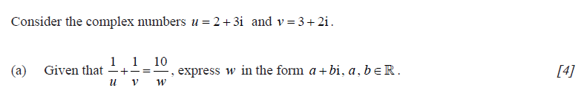

3.

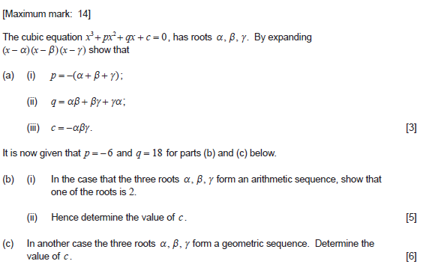

4.

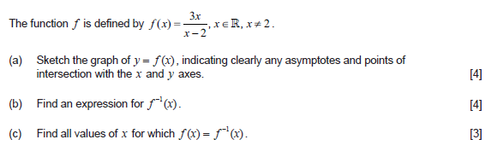

1. Solve
2.  b. 

Day Three

1. Given and , find the domain of .
2. Solve for 
3. If  and  , rewrite  in terms of t and u.



1. Given the function f(x), sketch the graph of 
2. Find  given that when  is divided by , the remainder is .

6. Find  if the coefficient of  in the expansion of  is .