**Poisson Distributjion: Exit Slip Name: _____________________**

1.

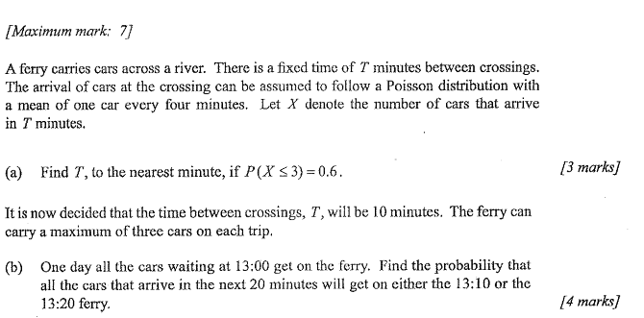

2.

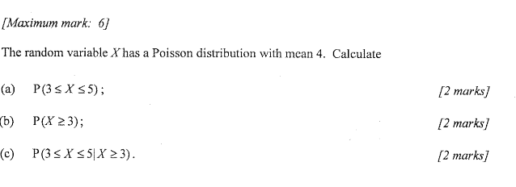

3.

