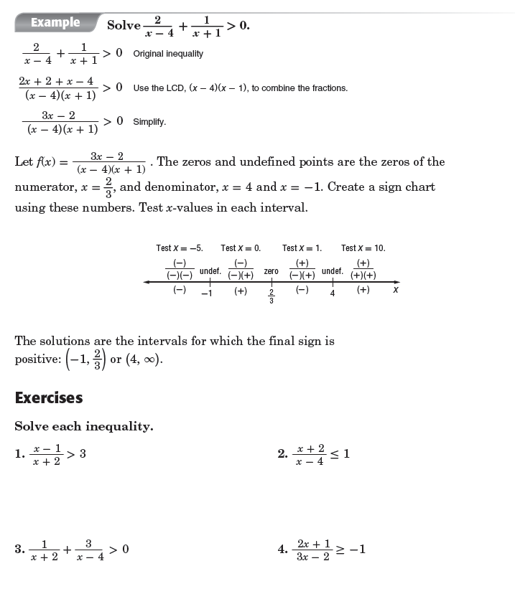

|  |  |
| --- | --- |
| 5. |  |
| 6. |  |

