IB Pre HL Exit Slip Name: ________________________

1.  is the parent function.
2. Graph .

 

1. 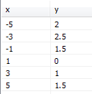 Find the equation for h(x) in terms of f(x).

Answer: __________________________

1. Given that  is a point on the graph of, find the coordinates of the point that it moves to under the transformation .

3) Find the point on  which is moved to  under the transformation .

1. Given 

Draw the graph of f(x) and on the same set of axes the graph of .